Online Appendix A. Summary Statistics

Online Appendix A1: Robustness of ESG High–Low Portfolios to Outlier Treatment and Grouping Method
This section examines whether the negative ESG return premium is driven by outliers or score distribution effects.
Specifically, we test the robustness of the High–Low (H–L) portfolio returns under three alternative constructions: (1) five-group quintile sorting instead of ten deciles, (2) winsorization of ESG scores and returns at the 1st–99th percentiles, and (3) re-estimation under both quintile grouping and winsorization. If ESG underperformance persists after removing extreme values and adjusting grouping granularity, the effect can be considered robust to data distribution.For each specification, firms are annually sorted by their ESG, E, S, and G pillar scores.We compute the High–Low return spreads (high ESG − low ESG) and report annualized means, standard deviations, cumulative returns, t-statistics, and significance levels based on Newey–West robust errors.

Appendix E shows that the negative ESG and G-factor premia remain stable across all outlier and grouping adjustments. Even after winsorizing both ESG scores and returns at the 1st–99th percentile and reducing portfolio granularity from deciles to quintiles, the overall ESG H–L spread stays negative and significant (−3.2% to −2.8% per year, p < 0.05). The Governance pillar consistently drives the overall pattern, with annualized underperformance between −7% and −8%, statistically significant at the 1% level. In contrast, the Environmental and Social factors exhibit weak or insignificant spreads, suggesting that ESG underpricing is primarily attributable to firm-level governance characteristics rather than environmental or social performance. These results confirm that the observed ESG return pattern is not caused by outliers or noise in the score distribution. The sign, direction, and magnitude of α remain robust to data treatment, indicating that the negative ESG premium is structurally embedded in the Chinese equity market rather than an artifact of data extremes.

Specification | Pillar | Mean Annual H–L Return (%) | Std. Dev. | Cumulative Return (%) | # of Positive Years | t-stat | Significance
Quintile (5 Groups) | Overall ESG | −3.19 | 4.26 | −50.98 | 3 / 16 | −2.99 | ***
 | E (Environmental) | −0.73 | 2.67 | −11.74 | 7 / 16 | −1.10 | n.s.
 | S (Social) | −1.24 | 2.71 | −19.79 | 5 / 16 | −1.82 | *
 | G (Governance) | −7.77 | 9.53 | −124.29 | 2 / 16 | −3.26 | ***
Winsorized + Quintile | Overall ESG | −2.81 | 4.02 | −44.95 | 3 / 16 | −2.80 | **
 | E (Environmental) | −0.42 | 2.81 | −6.71 | 7 / 16 | −0.60 | n.s.
 | S (Social) | −1.05 | 2.47 | −16.78 | 5 / 16 | −1.70 | n.s.
 | G (Governance) | −7.17 | 8.82 | −114.77 | 2 / 16 | −3.25 | ***
Decile (10 Groups) | Overall ESG | −3.01 | 5.77 | −48.14 | 3 / 16 | −2.08 | *
 | E (Environmental) | −0.71 | 4.49 | −11.35 | 7 / 16 | −0.63 | n.s.
 | S (Social) | −1.31 | 2.93 | −21.03 | 4 / 16 | −1.80 | *
 | G (Governance) | −9.06 | 13.27 | −144.98 | 3 / 16 | −2.73 | **

Online Appendix A2: Robustness Check — Lagged ESG Specification (OLS Regression)

This table reports OLS regressions of daily stock returns on lagged ESG scores. Each specification uses the ESG or E/S/G sub-scores from year t−1 to predict returns in year t. Standard errors are heteroskedasticity-consistent (HC3). Results show significantly negative coefficients for ESG, E, and S, indicating that higher ESG performance is associated with slightly lower subsequent returns, consistent with the “valuation premium” or “overpricing” hypothesis. The governance (G) coefficient is weakly positive and marginally significant, suggesting that governance quality may reflect distinct market information.

Variable | Coefficient | Std. Error | t-stat (z) | p-value | Significance
ESG Score (t−1) | −0.0010 | 0.0001 | −9.94 | 0.000 | ***
E Score (t−1) | −0.0006 | 0.0000 | −13.41 | 0.000 | ***
S Score (t−1) | −0.0010 | 0.0001 | −14.21 | 0.000 | ***
G Score (t−1) | +0.0002 | 0.0001 | +2.16 | 0.031 | **
Constant | 0.0558–0.0860 | (varies by model) | — | 0.000 | ***
Covariance type | HC3 robust
Observations | 45,199
R² (overall) | 0.003
Durbin–Watson | 2.139

Online Appendix B. Summary Statistics

Table B1: ESG Rating Coverage Ratio by GICS Industry (2007–2022)

This table reports the ESG rating coverage ratio by GICS Level 1 industry classification based on Wind industry codes as of February 2025. The coverage ratio is defined as the proportion of firms within each industry that have available ESG ratings in the CNRDS database during the sample period from 2005 to 2024. A higher ratio indicates broader ESG data availability and reporting penetration within the industry.

GICS Code | Industry (Level 1) | Coverage Ratio
10 | Energy | 0.650617
15 | Materials | 0.481439
20 | Industrials | 0.428281
25 | Consumer Discretionary | 0.467552
30 | Consumer Staples | 0.497683
35 | Health Care | 0.417248
40 | Financials | 0.520661
45 | Information Technology | 0.351297
50 | Telecommunication Services | 0.331250
55 | Utilities | 0.596691
60 | Real Estate | 0.761000

Table B2. Time Trend of ESG Rating Coverage and Scores (2007–2022)

This table reports the annual ESG rating coverage ratio and average ESG component scores across all rated companies. he coverage ratio represents the proportion of firms that have ESG ratings available in the CNRDS database each year. The sample spans from 2007 to 2022, capturing a period of rapid expansion in ESG disclosure and rating coverage.

Over the sample period, the ESG coverage ratio increased substantially from 27.5% in 2007 to 95.5% in 2022, corresponding to a total growth of 247% and a compound annual growth rate (CAGR) of 8.65%, reflecting broader ESG data availability and deeper integration of ESG reporting practices across industries.

In terms of ESG performance, the average overall ESG score rose from 18.74 to 31.62 (+68.7% total growth, 3.55% CAGR). This improvement was primarily driven by the remarkable growth in the Environmental (E) dimension, which surged from 6.07 to 37.06 (+510.5%, 12.82% CAGR), suggesting heightened corporate attention to environmental management and disclosure. The Social (S) score also doubled from 13.00 to 26.12 (+100.9%, 4.76% CAGR), indicating steady progress in social responsibility and employee-related practices. In contrast, the Governance (G) score declined modestly from 25.36 to 20.53 (–19.1%, –1.40% CAGR), implying a potential plateau or shifting emphasis away from traditional governance metrics.

Collectively, these trends highlight a pronounced and asymmetric evolution of ESG dimensions in China’s capital market—marked by the dominance of environmental improvements, stable social performance, and relative stagnation in governance quality—underpinned by the expanding breadth of ESG coverage and regulatory encouragement for sustainability reporting.

Year | Total Firms | Firms with ESG | Coverage Ratio (%) | Average ESG Score | Average E Score | Average S Score | Average G Score
2007 | 5,076 | 1,396 | 27.50 | 18.74 | 6.07 | 13.00 | 25.36
2008 | 5,076 | 1,454 | 28.64 | 21.11 | 7.68 | 15.95 | 26.19
2009 | 5,076 | 1,592 | 31.36 | 20.83 | 7.85 | 16.29 | 24.36
2010 | 5,076 | 1,924 | 37.90 | 18.60 | 7.29 | 17.52 | 19.27
2011 | 5,076 | 2,158 | 42.51 | 18.88 | 7.18 | 18.01 | 19.61
2012 | 5,076 | 2,281 | 44.94 | 22.75 | 8.37 | 21.89 | 23.52
2013 | 5,076 | 2,330 | 45.90 | 23.77 | 9.07 | 22.83 | 25.60
2014 | 5,076 | 2,446 | 48.19 | 23.87 | 9.70 | 22.98 | 25.79
2015 | 5,084 | 2,644 | 52.01 | 24.55 | 10.03 | 24.34 | 25.70
2016 | 5,084 | 2,955 | 58.12 | 24.75 | 10.48 | 24.92 | 24.32
2017 | 5,084 | 3,311 | 65.13 | 26.00 | 12.10 | 26.54 | 24.37
2018 | 5,084 | 3,414 | 67.15 | 27.21 | 13.24 | 27.35 | 25.53
2019 | 5,084 | 3,647 | 71.73 | 27.32 | 13.29 | 25.43 | 27.56
2020 | 5,084 | 4,179 | 82.20 | 27.48 | 14.66 | 25.41 | 26.30
2021 | 5,084 | 4,615 | 90.77 | 28.69 | 16.99 | 26.27 | 24.16
2022 | 5,084 | 4,853 | 95.46 | 31.62 | 37.06 | 26.12 | 20.53

Table B3. Annual ESG Rating Coverage Ratio by GICS Industry (2007–2022)

This table reports the annual ESG rating coverage ratio for firms across 11 GICS Level-1 industries, based on Wind industry classification as of February 2025. The coverage ratio is defined as the proportion of firms within each industry that have available ESG ratings in the CNRDS database in a given year. The sample period spans from 2007 to 2022 and captures the evolution of ESG data penetration across industries over time.

Over the fifteen-year sample period, ESG coverage expanded substantially across all industries, reflecting the rapid diffusion of sustainability disclosure practices in China’s capital market. The average coverage ratio increased from 0.43 in 2007 to 0.96 in 2022, corresponding to a +123% relative improvement.
Among industries, Information Technology (+0.79) and Telecommunication Services (+0.75) experienced the most pronounced increases, driven by regulatory encouragement for digital governance and information transparency. Health Care (+0.73) and Industrials (+0.70) also showed rapid adoption, consistent with heightened environmental and safety reporting standards. In contrast, Real Estate (+0.12) and Utilities (+0.38) exhibited slower growth, suggesting relatively stable or already high disclosure levels at the beginning of the sample period. The narrowing dispersion in 2022 — when nearly all industries achieved over 90% coverage — underscores the institutionalization of ESG reporting under China’s green finance and sustainability initiatives.

Panel A: Industries’ Annual ESG Rating Coverage Ratio
Year | Energy | Materials | Industrials | Consumer Discretionary | Consumer Staples | Health Care | Financials | Information Technology | Telecommunication Services | Utilities | Real Estate
2007 | 0.593 | 0.326 | 0.239 | 0.287 | 0.355 | 0.244 | 0.405 | 0.132 | 0.250 | 0.596 | 0.880
2008 | 0.617 | 0.350 | 0.250 | 0.293 | 0.363 | 0.253 | 0.405 | 0.143 | 0.250 | 0.603 | 0.890
2009 | 0.642 | 0.370 | 0.282 | 0.323 | 0.390 | 0.281 | 0.430 | 0.169 | 0.250 | 0.610 | 0.920
2010 | 0.691 | 0.451 | 0.350 | 0.382 | 0.459 | 0.341 | 0.479 | 0.240 | 0.250 | 0.632 | 0.930
2011 | 0.753 | 0.490 | 0.400 | 0.430 | 0.498 | 0.390 | 0.512 | 0.295 | 0.250 | 0.654 | 0.930
2012 | 0.765 | 0.512 | 0.420 | 0.466 | 0.521 | 0.407 | 0.529 | 0.325 | 0.250 | 0.676 | 0.940
2013 | 0.778 | 0.515 | 0.430 | 0.483 | 0.533 | 0.415 | 0.529 | 0.336 | 0.250 | 0.684 | 0.940
2014 | 0.790 | 0.539 | 0.459 | 0.506 | 0.560 | 0.439 | 0.545 | 0.352 | 0.250 | 0.713 | 0.940
2015 | 0.840 | 0.570 | 0.504 | 0.554 | 0.595 | 0.478 | 0.587 | 0.385 | 0.250 | 0.728 | 0.960
2016 | 0.889 | 0.633 | 0.567 | 0.626 | 0.653 | 0.524 | 0.678 | 0.451 | 0.375 | 0.750 | 0.960
2017 | 0.901 | 0.684 | 0.640 | 0.727 | 0.707 | 0.600 | 0.719 | 0.528 | 0.375 | 0.794 | 0.970
2018 | 0.901 | 0.703 | 0.660 | 0.745 | 0.737 | 0.618 | 0.810 | 0.545 | 0.375 | 0.816 | 0.970
2019 | 0.926 | 0.745 | 0.700 | 0.775 | 0.764 | 0.671 | 0.884 | 0.617 | 0.500 | 0.838 | 0.990
2020 | 0.951 | 0.846 | 0.812 | 0.858 | 0.888 | 0.793 | 0.926 | 0.742 | 0.750 | 0.904 | 1.000
2021 | 0.988 | 0.929 | 0.905 | 0.928 | 0.950 | 0.916 | 0.975 | 0.839 | 1.000 | 0.956 | 1.000
2022 | 0.988 | 0.964 | 0.943 | 0.967 | 0.981 | 0.975 | 1.000 | 0.923 | 1.000 | 0.978 | 1.000

Panel B: Industries’ Absolute Coverage Ratio Increase (2007-2022)
Industry | 2007 | 2022 | Increase (Δ)
Energy | 0.593 | 0.988 | +0.395
Materials | 0.326 | 0.964 | +0.638
Industrials | 0.239 | 0.943 | +0.704
Consumer Discretionary | 0.287 | 0.967 | +0.680
Consumer Staples | 0.355 | 0.981 | +0.626
Health Care | 0.244 | 0.975 | +0.731
Financials | 0.405 | 1.000 | +0.595
Information Technology | 0.132 | 0.923 | +0.791
Telecommunication Services | 0.250 | 1.000 | +0.750
Utilities | 0.596 | 0.978 | +0.382
Real Estate | 0.880 | 1.000 | +0.120

Table B4. Average Annual Growth Rate of ESG Coverage Ratio by Industry (2007–2022)

This table reports the compound annual growth rate (CAGR) of the ESG rating coverage ratio across 11 GICS Level-1 industries during the sample period from 2007 to 2022. The growth rate is calculated as the compound annual percentage increase in the proportion of firms with available ESG ratings in the CNRDS database. A higher CAGR indicates a faster rate of ESG adoption within the corresponding industry. Information Technology, Telecommunication Services, and Health Care exhibit the highest growth rates, suggesting rapid expansion of ESG data coverage in these sectors, while Real Estate and Utilities show slower growth. The overall average annual growth rate across all industries is approximately 7.23%.

GICS Code | Industry | Avg. Annual Growth Rate
45 | Information Technology | 0.1383
50 | Telecommunication Services | 0.0968
35 | Health Care | 0.0967
20 | Industrials | 0.0959
25 | Consumer Discretionary | 0.0843
15 | Materials | 0.0749
30 | Consumer Staples | 0.0700
40 | Financials | 0.0621
10 | Energy | 0.0346
55 | Utilities | 0.0336
60 | Real Estate | 0.0086

Note: The CAGR is computed as $({\left(\frac{EndValue}{StartValue}\right)}^{1/Years}-1)$. Industries with lower initial ESG coverage (e.g., IT and Health Care) show higher relative growth, reflecting the diffusion of ESG disclosure practices across previously under-covered sectors.

Table B5. Average ESG Ratings by Industry (2007–2022)

This table presents the average ESG ratings across GICS Level-1 industries, based on firm-level data from the Wind database (2007–2022), as of February 2025. Consumer Staples, Materials, and Health Care exhibit the highest average ESG scores, reflecting stronger sustainability disclosure and compliance practices. In contrast, Real Estate and Telecommunication Services show relatively lower ESG performance, suggesting slower progress in ESG adoption within these sectors.
The table reports the average firm-level ESG scores aggregated by industry over the period 2005–2022. Higher values indicate stronger environmental, social, and governance performance as measured by the CNRDS database.

Industry | Average ESG Score
30 Consumer Staples | 33.70
15 Materials | 30.54
35 Health Care | 30.03
10 Energy | 27.08
25 Consumer Discretionary | 23.72
20 Industrials | 23.60
55 Utilities | 22.83
40 Financials | 22.73
45 Information Technology | 21.30
60 Real Estate | 19.71
50 Telecommunication Services | 18.65

Table B6. Industry-Level ESG Rating Trends (2007–2022)

This table reports the time-series evolution of average ESG ratings across 11 GICS Level-1 industries from 2007 to 2022, based on the Wind database as of February 2025. The ESG rating represents the mean value of firm-level ESG scores within each industry and year. Industries such as Consumer Staples, Materials, and Health Care consistently maintain higher ESG ratings, reflecting their stronger disclosure and compliance behavior. In contrast, Real Estate and Telecommunication Services exhibit relatively lower scores and slower improvement over time. The overall upward trend across all industries highlights the progressive enhancement of ESG standards and corporate sustainability awareness among Chinese listed firms.

Year | Energy | Materials | Industrials | Consumer Discretionary | Consumer Staples | Health Care | Financials | Information Technology | Telecommunication Services | Utilities | Real Estate
2007 | 20.18 | 22.45 | 16.59 | 17.24 | 25.75 | 23.70 | 14.55 | 15.74 | 16.08 | 15.74 | 14.46
2008 | 24.11 | 23.82 | 19.52 | 19.46 | 27.61 | 25.92 | 18.41 | 17.97 | 17.67 | 17.76 | 17.46
2009 | 22.18 | 24.62 | 19.24 | 18.82 | 27.41 | 24.72 | 18.24 | 17.04 | 13.99 | 19.21 | 17.08
2010 | 20.72 | 22.12 | 16.92 | 17.16 | 24.25 | 21.91 | 15.44 | 15.95 | 17.19 | 16.10 | 15.11
2011 | 20.25 | 22.61 | 17.48 | 17.49 | 24.57 | 22.14 | 15.75 | 16.04 | 19.33 | 16.31 | 14.93
2012 | 23.42 | 26.64 | 20.99 | 21.38 | 30.07 | 26.78 | 20.77 | 19.47 | 19.26 | 20.17 | 18.06
2013 | 26.01 | 28.00 | 22.15 | 22.58 | 30.16 | 27.89 | 23.58 | 19.38 | 19.80 | 21.29 | 19.46
2014 | 26.57 | 27.80 | 22.39 | 22.59 | 30.58 | 28.22 | 21.39 | 19.33 | 23.15 | 21.55 | 20.92
2015 | 26.46 | 28.97 | 23.07 | 22.78 | 31.73 | 28.66 | 22.94 | 20.70 | 23.28 | 22.38 | 18.85
2016 | 26.88 | 29.64 | 23.38 | 23.07 | 32.41 | 28.75 | 22.07 | 20.32 | 14.23 | 22.44 | 19.68
2017 | 29.81 | 31.28 | 24.33 | 23.85 | 34.24 | 29.83 | 24.46 | 21.88 | 19.64 | 24.07 | 20.77
2018 | 29.77 | 32.31 | 25.49 | 25.48 | 35.91 | 31.11 | 25.46 | 22.90 | 22.66 | 26.05 | 21.43
2019 | 29.29 | 33.73 | 25.18 | 25.61 | 37.95 | 31.75 | 24.11 | 22.12 | 15.92 | 26.31 | 21.65
2020 | 31.76 | 34.49 | 25.31 | 25.22 | 37.08 | 31.20 | 25.72 | 22.33 | 15.55 | 26.21 | 23.63
2021 | 32.11 | 35.84 | 26.19 | 27.17 | 38.95 | 32.59 | 27.23 | 23.21 | 17.34 | 27.80 | 24.76
2022 | 34.10 | 39.52 | 28.65 | 29.52 | 44.56 | 39.55 | 26.62 | 24.88 | 22.97 | 31.10 | 25.37

ESG ratings are industry-average firm scores on a 0–100 scale, derived from CNRDS ESG assessments. Higher values indicate stronger environmental, social, and governance performance. The results show that ESG ratings generally improved across all industries during 2007–2022, with pronounced acceleration after 2015. The high-ESG sectors (Consumer Staples, Materials, and Health Care) exhibit consistently strong performance, while Real Estate and Telecommunication Services lag behind due to limited disclosure and slower ESG adoption.

Table B7. Average Annual Growth Rate of ESG Ratings by Industry (2007–2022)

This table reports the average annual growth rate (CAGR) of ESG scores for each GICS Level-1 industry, calculated from 2007 to 2022 using the Wind ESG database as of February 2025. The growth rate measures the compound annual increase in each industry’s average ESG rating over the sample period. A higher value indicates faster improvement in ESG performance.

The overall average annual growth rate across all industries is 3.64%, suggesting a steady upward trend in corporate ESG performance among Chinese listed firms. Traditional and regulated sectors such as Utilities and Financials demonstrate the most rapid ESG improvement, likely driven by policy mandates and investor scrutiny. In contrast, Telecommunication Services and Information Technology show relatively modest growth, reflecting slower adaptation of ESG disclosure and reporting frameworks in these sectors.

Industry | Avg. Annual Growth
Utilities | 0.0464
Financials | 0.0411
Materials | 0.0384
Real Estate | 0.0382
Consumer Staples | 0.0372
Industrials | 0.0371
Consumer Discretionary | 0.0365
Energy | 0.0356
Health Care | 0.0347
Information Technology | 0.0310
Telecommunication Services | 0.0241

Table B8. Average Industry-level E, S, G Ratings (2007–2022)

This table reports the average environmental (E), social (S), and governance (G) ratings across industries from 2007 to 2022. The results reveal that the Environmental (E) dimension exhibits the highest cross-industry volatility (σ = 5.52), indicating substantial heterogeneity in firms’ environmental practices and disclosure intensity. In comparison, the Social (S) and Governance (G) dimensions show lower volatilities (σ = 3.57 and 3.89, respectively), suggesting more consistent performance across sectors.

Industries such as Materials, Consumer Staples, and Health Care exhibit higher overall ESG ratings, reflecting stronger sustainability engagement and governance frameworks. In contrast, Telecommunication Services and Real Estate display relatively lower average scores, particularly in the environmental domain, implying uneven ESG integration across industry structures.

E, S, and G represent the environmental, social, and governance dimensions of ESG ratings, respectively. Values indicate the mean rating across all listed firms in each industry from 2007 to 2022, and volatilities (standard deviations) capture the degree of dispersion in.

Industry | E Rating | S Rating | G Rating
10 Energy | 15.32 | 28.84 | 27.50
15 Materials | 23.37 | 23.22 | 23.02
20 Industrials | 12.66 | 23.59 | 23.01
25 Consumer Discretionary | 11.54 | 21.48 | 24.37
30 Consumer Staples | 17.91 | 29.67 | 28.80
35 Health Care | 17.18 | 25.74 | 24.02
40 Financials | 8.06 | 23.00 | 33.54
45 Information Technology | 9.44 | 22.27 | 21.38
50 Telecommunication Services | 6.05 | 17.94 | 27.06
55 Utilities | 11.46 | 25.30 | 29.15
60 Real Estate | 5.07 | 19.51 | 31.73

Table B9. Industry-level Environmental (E) Ratings by Year (2007–2022)

This table reports the annual average Environmental (E) ratings of listed firms in China across the 11 GICS Level-1 industries from 2007 to 2022, based on data from the Wind ESG database as of February 2025.
The E ratings capture firms’ environmental management quality, including emissions control, resource efficiency, and environmental disclosure practices.

Across all industries, Environmental (E) scores exhibit a steady upward trend, particularly after 2015.
The Materials and Consumer Staples sectors show the most pronounced improvement, reflecting increasing regulatory pressure and stronger environmental disclosure standards in heavy manufacturing and essential goods production. In contrast, Real Estate and Telecommunication Services remain relatively low in E performance, suggesting slower adaptation to green transformation and limited environmental reporting initiatives.

Overall, the sharp increase observed in 2021–2022 across most industries corresponds with the tightening of ESG disclosure guidelines and China’s commitment to carbon neutrality goals announced in 2020.

Year | Energy | Materials | Industrials | Consumer Discretionary | Consumer Staples | Health Care | Financials | Information Technology | Telecommunication Services | Utilities | Real Estate
2007 | 6.28 | 10.88 | 4.31 | 5.42 | 8.76 | 7.30 | 3.03 | 3.71 | 1.48 | 4.66 | 2.44
2008 | 8.07 | 12.20 | 6.22 | 6.33 | 9.34 | 9.24 | 5.47 | 5.49 | 1.52 | 7.18 | 3.99
2009 | 8.60 | 12.81 | 6.60 | 6.10 | 9.69 | 9.23 | 5.88 | 4.99 | 2.25 | 7.72 | 4.22
2010 | 8.20 | 12.58 | 6.19 | 5.54 | 9.05 | 7.60 | 4.78 | 4.64 | 2.24 | 7.17 | 3.51
2011 | 9.64 | 12.62 | 6.26 | 5.37 | 8.90 | 7.81 | 4.84 | 4.32 | 2.25 | 6.33 | 2.89
2012 | 9.46 | 15.01 | 7.28 | 6.83 | 9.95 | 9.96 | 4.93 | 4.80 | 2.23 | 6.72 | 2.99
2013 | 9.80 | 16.91 | 7.65 | 7.38 | 10.46 | 11.25 | 4.97 | 5.09 | 4.04 | 7.10 | 3.11
2014 | 12.41 | 17.23 | 8.48 | 7.88 | 11.23 | 12.64 | 5.40 | 5.11 | 4.06 | 7.96 | 3.28
2015 | 12.67 | 18.34 | 8.71 | 8.03 | 11.25 | 12.58 | 5.27 | 5.38 | 4.08 | 9.16 | 3.21
2016 | 13.40 | 19.60 | 9.40 | 8.08 | 11.61 | 12.46 | 5.90 | 5.64 | 5.25 | 9.35 | 3.02
2017 | 16.53 | 22.64 | 10.89 | 9.05 | 15.47 | 14.47 | 6.21 | 6.47 | 1.88 | 10.70 | 3.84
2018 | 17.73 | 23.97 | 11.91 | 9.90 | 18.57 | 15.85 | 7.22 | 7.48 | 3.10 | 11.06 | 4.13
2019 | 17.87 | 24.66 | 11.88 | 10.01 | 18.57 | 15.00 | 7.29 | 7.80 | 1.65 | 10.99 | 4.56
2020 | 19.80 | 27.13 | 13.29 | 11.18 | 19.27 | 15.69 | 9.01 | 8.69 | 2.44 | 13.01 | 5.86
2021 | 19.89 | 29.75 | 15.63 | 13.70 | 21.68 | 19.11 | 11.12 | 10.50 | 8.62 | 15.22 | 6.79
2022 | 39.55 | 52.62 | 33.11 | 34.97 | 52.57 | 46.87 | 22.00 | 26.56 | 18.96 | 35.24 | 21.89

Table B10. Industry-level Social (S) Ratings by Year (2007–2022)

This table reports the annual average Social (S) ratings of listed firms in China across the 11 GICS Level-1 industries from 2007 to 2022, based on data from the Wind ESG database as of February 2025.
The S ratings capture firms’ social responsibility performance, including labor protection, community engagement, supply chain management, product safety, and social disclosure practices.

Across all industries, Social (S) scores demonstrate a consistent upward trend, reflecting the growing emphasis on corporate social responsibility (CSR) and stakeholder-oriented governance in China. The Consumer Staples and Energy industries show the highest average S ratings, supported by strong employee welfare programs and improved product quality supervision. In contrast, Telecommunication Services and Real Estate sectors record comparatively lower scores, indicating slower progress in CSR integration and social transparency.

The moderate rise in S ratings after 2015 coincides with the introduction of CSR reporting guidelines by Chinese regulatory authorities, while the overall stabilization after 2020 suggests a more mature stage of social governance implementation among large listed firms.

Year | Energy | Materials | Industrials | Consumer Discretionary | Consumer Staples | Health Care | Financials | Information Technology | Telecommunication Services | Utilities | Real Estate
2007 | 20.42 | 11.86 | 13.16 | 12.25 | 14.88 | 12.95 | 13.95 | 11.28 | 17.15 | 14.78 | 11.88
2008 | 24.43 | 14.28 | 16.10 | 14.27 | 18.87 | 16.91 | 17.67 | 14.14 | 20.21 | 18.87 | 14.44
2009 | 24.76 | 14.56 | 16.64 | 14.28 | 20.79 | 17.22 | 17.66 | 13.61 | 8.91 | 19.81 | 15.49
2010 | 23.72 | 16.40 | 17.45 | 15.83 | 21.91 | 19.37 | 17.05 | 16.31 | 10.79 | 19.66 | 16.08
2011 | 24.06 | 16.90 | 17.65 | 16.55 | 22.88 | 20.26 | 18.11 | 16.96 | 19.68 | 19.31 | 16.15
2012 | 27.60 | 20.57 | 21.12 | 20.53 | 27.74 | 25.12 | 22.27 | 20.88 | 13.64 | 23.18 | 20.21
2013 | 29.62 | 21.99 | 22.60 | 21.09 | 29.02 | 25.72 | 24.87 | 20.31 | 9.99 | 24.75 | 20.86
2014 | 30.51 | 22.40 | 22.61 | 21.50 | 30.45 | 26.18 | 22.95 | 20.19 | 20.38 | 23.94 | 19.73
2015 | 30.15 | 24.50 | 24.17 | 22.03 | 32.18 | 27.27 | 22.54 | 22.54 | 14.03 | 24.98 | 18.81
2016 | 29.81 | 24.90 | 25.18 | 22.41 | 32.57 | 26.95 | 22.72 | 23.38 | 13.75 | 27.02 | 19.56
2017 | 32.91 | 26.46 | 26.51 | 23.83 | 33.12 | 28.81 | 26.46 | 25.28 | 18.53 | 29.12 | 21.94
2018 | 32.16 | 27.28 | 27.67 | 25.18 | 34.64 | 29.12 | 25.00 | 25.52 | 31.35 | 30.73 | 22.12
2019 | 30.42 | 26.06 | 25.27 | 23.09 | 33.77 | 27.23 | 23.00 | 23.49 | 21.23 | 29.10 | 21.11
2020 | 30.93 | 26.69 | 25.12 | 22.71 | 32.03 | 26.99 | 25.99 | 23.48 | 15.29 | 27.73 | 22.99
2021 | 30.26 | 27.06 | 25.75 | 24.42 | 33.02 | 27.48 | 27.06 | 24.63 | 15.90 | 29.95 | 23.47
2022 | 31.84 | 26.46 | 26.31 | 23.10 | 32.31 | 29.07 | 25.55 | 23.70 | 23.33 | 30.84 | 25.29

Table B11. Yearly Governance (G) Ratings by Industry (2007–2022)

This table presents the average Governance (G) ratings of listed firms across 11 GICS Level-1 industries from 2007 to 2022, based on data obtained from the Wind ESG database (February 2025 update).

The G score reflects the strength of corporate governance, including board structure, ownership concentration, and information transparency. Governance (G) scores generally exhibit a slight upward trend from 2007 to 2020 across most industries, reflecting enhancements in corporate governance practices in China’s capital market. The Financials, Utilities, and Real Estate sectors consistently rank among the top performers in G ratings, indicating strong institutional oversight and regulatory compliance. By contrast, Information Technology and Materials display lower and more volatile G scores, suggesting less mature governance structures and higher firm-level heterogeneity.

The drop after 2021 partly reflects data coverage limitations in the latest Wind updates rather than true deterioration in governance quality.

Year | Energy | Materials | Industrials | Consumer Discretionary | Consumer Staples | Health Care | Financials | Information Technology | Telecommunication Services | Utilities | Real Estate
2007 | 25.81 | 23.77 | 24.27 | 24.74 | 28.65 | 27.59 | 27.10 | 22.03 | 30.29 | 29.10 | 29.43
2008 | 26.41 | 23.80 | 26.30 | 26.76 | 28.40 | 26.81 | 28.44 | 23.27 | 28.87 | 27.06 | 31.31
2009 | 25.08 | 23.50 | 23.71 | 23.81 | 27.12 | 24.10 | 28.94 | 21.01 | 29.04 | 27.63 | 28.96
2010 | 20.22 | 18.81 | 17.95 | 19.53 | 22.34 | 19.33 | 21.77 | 17.35 | 28.31 | 20.95 | 24.43
2011 | 18.74 | 19.19 | 18.49 | 20.16 | 23.33 | 19.63 | 23.38 | 17.39 | 34.97 | 21.41 | 24.20
2012 | 23.98 | 22.62 | 22.39 | 23.46 | 28.79 | 23.71 | 28.64 | 21.32 | 32.10 | 26.63 | 27.40
2013 | 27.51 | 24.12 | 24.36 | 25.34 | 29.88 | 26.54 | 35.45 | 22.33 | 41.06 | 29.88 | 32.06
2014 | 29.42 | 24.77 | 24.80 | 25.48 | 30.17 | 25.92 | 34.82 | 22.22 | 32.56 | 29.33 | 32.66
2015 | 28.44 | 24.10 | 24.26 | 25.41 | 29.61 | 26.01 | 35.94 | 23.36 | 32.19 | 30.14 | 33.21
2016 | 28.32 | 23.35 | 23.14 | 23.85 | 28.39 | 24.31 | 33.22 | 21.28 | 22.09 | 29.42 | 32.78
2017 | 28.67 | 23.21 | 22.89 | 23.50 | 29.65 | 24.24 | 34.75 | 22.05 | 25.92 | 30.01 | 33.32
2018 | 29.07 | 24.20 | 24.06 | 25.90 | 30.12 | 25.17 | 35.64 | 22.90 | 35.70 | 31.11 | 32.64
2019 | 31.09 | 25.85 | 26.05 | 28.13 | 34.06 | 27.06 | 39.81 | 24.09 | 23.25 | 34.29 | 37.05
2020 | 32.74 | 25.18 | 24.45 | 26.46 | 31.67 | 25.45 | 39.48 | 23.20 | 25.52 | 33.95 | 39.60
2021 | 31.19 | 22.90 | 22.59 | 25.01 | 29.87 | 22.73 | 37.47 | 21.11 | 20.60 | 30.48 | 37.42
2022 | 27.53 | 19.09 | 19.68 | 20.60 | 24.55 | 19.89 | 33.32 | 17.66 | 24.18 | 29.54 | 29.60

Table B12. Summary Statistics of ESG Dimension Scores (Quantiles)

This table reports the 25th, 50th, and 75th percentile values of the firm-level average scores for each ESG dimension (E, S, and G) across all listed firms included in the CNRDS database from 2007 to 2022. The results show that G (Governance) scores are more concentrated and higher in central tendency, while E (Environmental) scores exhibit the widest dispersion, reflecting substantial heterogeneity in environmental performance across industries.

Figure 10 and Table 12 jointly depict the cross-sectional dispersion of the three ESG sub-dimensions across Chinese listed firms from 2007 to 2022.The Environmental (E) scores exhibit the widest dispersion and the lowest central tendency (median = 11.54), with a long lower tail extending toward zero. This pattern implies that environmental practices remain highly uneven across industries — while a small fraction of firms achieve relatively high environmental ratings, the majority perform modestly, reflecting heterogeneous environmental management maturity and disclosure practices.

In contrast, the Social (S) and Governance (G) scores display higher medians (23.22 and 27.06, respectively) and more compact distributions, suggesting that Chinese listed firms have achieved greater convergence in social responsibility and governance standards. The narrower interquartile range (IQR) of G ratings (23.52 – 28.97) indicates that governance-related criteria — such as board independence, shareholder protection, and information transparency — are more uniformly adopted across industries.

Dimension | 25% | 50% (Median) | 75%
E | 8.75 | 11.54 | 16.25
S | 21.88 | 23.22 | 25.52
G | 23.52 | 27.06 | 28.97

Table B13. Rank Correlation Matrices among ESG Dimensions

This table reports the average Environmental (E), Social (S), and Governance (G) scores for each GICS Level 1 industry, averaged across listed firms from 2007 to 2022. The ranking within each dimension is shown in the adjacent columns, with rank 1 indicating the highest-performing industry.

Industries such as Consumer Staples and Energy rank consistently high in both the E and S dimensions, while Financials and Real Estate exhibit stronger performance in the G (Governance) dimension. This cross-dimensional divergence highlights varying institutional and regulatory emphasis across sectors.

Industry (GICS Level 1) | E Score | E Rank | S Score | S Rank | G Score | G Rank
Materials | 23.37 | 1 | 23.22 | 6 | 23.02 | 9
Consumer Staples | 17.91 | 2 | 29.67 | 1 | 28.80 | 4
Health Care | 17.18 | 3 | 25.74 | 3 | 24.02 | 8
Energy | 15.32 | 4 | 28.84 | 2 | 27.50 | 5
Industrials | 12.66 | 5 | 23.59 | 5 | 23.01 | 10
Consumer Discretionary | 11.54 | 6 | 21.48 | 9 | 24.37 | 7
Utilities | 11.46 | 7 | 25.30 | 4 | 29.15 | 3
Information Technology | 9.44 | 8 | 22.27 | 8 | 21.38 | 11
Financials | 8.06 | 9 | 23.00 | 7 | 33.54 | 1
Telecommunication Services | 6.05 | 10 | 17.94 | 11 | 27.06 | 6
Real Estate | 5.07 | 11 | 19.51 | 10 | 31.73 | 2

Table B14. Rank Correlation Matrices among ESG Dimensions

This table presents both Spearman’s ρ and Kendall’s τ rank correlation matrices across Environmental (E), Social (S), and Governance (G) rankings at the industry level. A strong positive relationship is found between E and S dimensions (ρ = 0.755, τ = 0.564), suggesting a consistent pattern across environmental and social criteria, while the G dimension appears relatively independent from the other two.

 | E rank | S rank | G rank
Spearman ρ
E rank | 1.000 | 0.755 | -0.391
S rank | 0.755 | 1.000 | 0.018
G rank | -0.391 | 0.018 | 1.000
Kendall τ
E rank | 1.000 | 0.564 | -0.273
S rank | 0.564 | 1.000 | 0.018
G rank | -0.273 | 0.018 | 1.000

Table B15. Pairwise Rank Correlation Tests (Spearman and Kendall)

This table summarizes pairwise rank correlation tests among the Environmental (E), Social (S), and Governance (G) dimensions at the industry level.
Both Spearman and Kendall tests confirm a statistically significant positive association between E and S rankings, while G rankings show weak or insignificant relationships with the other two dimensions. Adjusted p-values are computed using the Holm–Bonferroni method to account for multiple testing.

Pair | Spearman ρ | p | Adj. p | Kendall τ | p | Adj. p | N
E vs S | 0.755* | 0.007 | 0.022 | 0.564 | 0.017 | 0.050 | 11
E vs G | -0.391 | 0.235 | 0.469 | -0.273 | 0.283 | 0.566 | 11
S vs G | 0.018 | 0.958 | 0.958 | 0.018 | 1.000 | 1.000 | 11

(Significance levels: *** p<0.01，** p<0.05，* p<0.1)

Table B16. Industry Rank Consistency across E/S/G Dimensions

This table reports the consistency of industry rankings across Environmental (E), Social (S), and Governance (G) dimensions. The Rank Std. column measures the standard deviation of each industry’s ranking across the three dimensions, while Rank Range represents the difference between the highest and lowest ranks. Average Rank denotes the mean ranking across E, S, and G.

A lower Rank Std. and Range indicate higher cross-dimensional stability. For example, Consumer Staples and Energy industries exhibit highly consistent ESG performance across dimensions (Rank Std. = 1.53), suggesting balanced sustainability practices. In contrast, Real Estate and Financials show larger variation across E/S/G, implying greater divergence between environmental and governance aspects.

Industry Name | Rank Std. | Rank Range | Average Rank
30 Consumer Staples | 1.53 | 3 | 2.33
10 Energy | 1.53 | 3 | 3.67
25 Consumer Discretionary | 1.53 | 3 | 7.33
45 Information Technology | 1.73 | 3 | 9.00
55 Utilities | 2.08 | 4 | 4.67
50 Telecommunication Services | 2.65 | 5 | 9.00
35 Health Care | 2.89 | 5 | 4.67
20 Industrials | 2.89 | 5 | 6.67
15 Materials | 4.04 | 8 | 5.33
40 Financials | 4.16 | 8 | 5.67
60 Real Estate | 4.93 | 9 | 7.67

Table B17. Cross-Year Stability of Industry ESG Ranking (2007–2022)

This table summarizes cross-year stability of industry rankings in Environmental (E), Social (S), and Governance (G). “Std.” is the standard deviation of yearly ranks (lower = more stable). “Range” is the difference between the best and worst ranks (lower = more stable). “Entropy” is Shannon entropy (base-2) computed from the empirical distribution of yearly ranks (lower = more concentrated = more stable). Lower entropy indicates that an industry tends to occupy fewer rank positions over time (i.e., higher stability). All statistics are computed from yearly industry ranks over 2007–2022 using the CNRDS dataset. Missing years (if any) are excluded before calculation.

Overall, Materials, Energy, and Information Technology exhibit the most stable rankings across the Environmental, Social, and Governance dimensions respectively, while Telecommunication Services shows the greatest volatility—particularly in S and G scores—indicating substantial cross-year rank fluctuations; meanwhile, Industrials maintains the lowest S-range, reflecting relatively consistent performance in the social dimension.

Industry (GICS L1) | E Std. | S Std. | G Std. | E Range | S Range | G Range | E Entropy (bits) | S Entropy (bits) | G Entropy (bits)
Industrials | 0.781 | 0.658 | 0.583 | 2 | 2 | 2 | 1.420 | 1.420 | 1.248
Information Technology | 0.500 | 1.368 | 0.331 | 1 | 4 | 1 | 1.000 | 2.108 | 0.544
Consumer Discretionary | 0.599 | 0.857 | 0.808 | 2 | 3 | 2 | 1.122 | 1.772 | 1.546
Utilities | 0.661 | 0.696 | 0.935 | 2 | 2 | 3 | 1.406 | 1.406 | 1.805
Consumer Staples | 0.768 | 0.704 | 0.829 | 2 | 2 | 3 | 1.477 | 1.366 | 1.544
Real Estate | 0.464 | 1.171 | 0.696 | 1 | 4 | 3 | 0.896 | 2.149 | 1.372
Materials | 0.000 | 1.590 | 0.882 | 0 | 5 | 3 | 0.000 | 2.399 | 1.677
Health Care | 0.750 | 1.111 | 0.827 | 2 | 4 | 3 | 1.505 | 1.921 | 1.649
Energy | 0.827 | 0.496 | 1.446 | 2 | 1 | 6 | 1.579 | 0.989 | 2.406
Financials | 0.500 | 1.685 | 1.379 | 1 | 6 | 5 | 1.000 | 2.625 | 1.975
Telecommunication Services | 0.464 | 3.495 | 3.706 | 1 | 9 | 10 | 0.896 | 1.967 | 2.397

Table B18. Composite Stability of Industry ESG Rankings (2007–2022)

This table summarizes the overall temporal stability of ESG (Environmental, Social, and Governance) rankings across eleven GICS first-level industries. The Stability Score combines three indicators—variance, rank range, and Shannon entropy—using the weights 0.50, 0.25, and 0.25, respectively, averaged over the three ESG pillars.
A lower Stability Score indicates greater consistency of an industry’s relative ESG ranking over time (i.e., less cross-year volatility).
Industries such as Industrials, Information Technology, and Consumer Discretionary show the most stable ESG performance over 2007–2022, whereas Financials and Energy display higher cross-year variability, reflecting more cyclical ESG evaluations.

Rank | Industry (GICS L1) | Stability Score
1 | Industrials | 1.071
2 | Information Technology | 1.176
3 | Consumer Discretionary | 1.244
4 | Consumer Staples | 1.244
5 | Utilities | 1.268
6 | Real Estate | 1.380
7 | Materials | 1.557
8 | Health Care | 1.586
9 | Energy | 1.668
10 | Financials | 2.299

(Weights: Var 0.50, Range 0.25, Entropy 0.25)

Table B19. Descriptive Statistics: Firms With vs. Without ESG Ratings

This table reports the completeness of key firm‐level variables — market capitalization, price‐to‐book ratio, and daily returns — for firms with and without ESG ratings from the Wind database (2007–2022). “Valid” refers to non-zero and non-missing observations. “Invalid” includes zero or missing values. The results show that financial data are nearly complete for firms with ESG ratings, while almost entirely missing for firms without ratings, implying that ESG coverage bias largely reflects underlying data availability rather than selection by rating agencies.

Data are obtained from the Wind Financial Database (February 2025 extraction). Percentages are calculated relative to total firm-year observations within each subgroup. The results indicate that nearly all non-ESG-rated firms lack valid financial data across key variables, whereas ESG-rated firms exhibit high data completeness, supporting the interpretation that ESG coverage bias arises from differences in data disclosure and availability.

Variable | ESG-Rated Firms | Valid (Non-Zero, Non-Missing) | Invalid (Zero or Missing) | Non-ESG-Rated Firms | Valid (Non-Zero, Non-Missing) | Invalid (Zero or Missing) | Zero Values | Missing Values
Market Capitalization | N = 45,199 | 44,206 (97.8 %) | 993 (2.2 %) | N = 36,081 | 0 (0.0 %) | 36,081 (100.0 %) | 36,017 | 64
Price-to-Book Ratio | N = 45,199 | 28,798 (63.7 %) | 16,401 (36.3 %) | N = 36,081 | 12 (0.0 %) | 36,069 (100.0 %) | 1,240 | 34,829
Daily Return | N = 45,199 | 44,184 (97.8 %) | 1,015 (2.2 %) | N = 36,081 | 0 (0.0 %) | 36,081 (100.0 %) | 35,921 | 160

Table B20. Portfolio Tests on ESG Deciles: Average and High–Low Returns (2007–2022)

This table presents ESG-based portfolio tests that examine whether firms with higher ESG scores deliver different average returns than those with lower ESG scores. In each specification, firms are sorted annually into deciles (or quintiles) based on their ESG scores, and portfolio returns are computed accordingly. In Panel C, both annual compounded and daily returns are computed using value-weighted portfolios.

Panel A shows that high-ESG firms earn significantly lower annual returns than low-ESG firms at the 10% level, suggesting a potential “ESG premium” (investors accept lower returns for sustainability). Panels B and C provide robustness checks using fewer groups and market-value weighting. While the equal-weighted quintile test (Panel B) shows no significance, the value-weighted daily test (Panel C) yields marginal significance at the 10% level, implying that ESG underperformance is more pronounced in large-cap stocks.

Panel | Specification | Weighting | Frequency | Significance Level | Result Summary
A. 10 Deciles (Equal-Weighted) | Firms are sorted annually into 10 deciles by ESG scores (Decile 1 = highest ESG). Portfolio returns are averaged annually. | Equal-weighted | Annual | 10% | ESG_HL mean = −3.01, t = −2.99, p < 0.01 → significant (negative premium).
B. 5 Deciles (Equal-Weighted) | Firms are re-sorted into 5 deciles. Annual equal-weighted returns computed. | Equal-weighted | Annual | 5% | ESG_HL mean = −3.19, t = −2.08, p < 0.1 → not significant.
C. 5 Deciles (Value-Weighted) | Firms are grouped into 5 deciles by ESG, weighted by market capitalization. Both daily and annual compounded returns are computed. | Value-weighted | Daily & Annual | 10% | Annual HL: t = −1.40, p = 0.182 (ns); Daily HL: t = −1.66, p = 0.096 → significant at 10%.

Notes. This table summarizes portfolio-level tests on ESG-sorted portfolios. ESG_HL denotes the return difference between the highest-ESG (Decile 1) and lowest-ESG (Decile 10 or 5) portfolios.
(Significance levels: *** p<0.01，** p<0.05，* p<0.1)

Table B21. Portfolio Tests on Environmental (E) Deciles: Average and High–Low Returns (2007–2022)

This table presents portfolio tests based on firms’ Environmental (E) pillar scores to examine whether companies with higher environmental performance exhibit different average returns from those with lower scores.
Firms are sorted annually into deciles or quintiles according to their E scores, and portfolio returns are computed using both equal- and value-weighted methods.
Panel A applies a 10-decile equal-weighted sort, Panel B re-sorts into 5 deciles, and Panel C computes both annual and daily returns using value-weighted portfolios. Overall, none of the E-pillar tests yield statistically significant results, implying that environmental performance alone does not generate abnormal returns.

Panel | Specification | Weighting | Frequency | Significance Level | Result Summary
A. 10 Deciles (Equal-Weighted) | Firms are sorted annually into 10 deciles by E scores (Decile 1 = highest E). Portfolio returns are averaged annually. | Equal-weighted | Annual | 10% | E_HL mean = −0.71, t = −0.54, p = 0.60 → not significant.
B. 5 Deciles (Equal-Weighted) | Firms are re-sorted into 5 deciles. Annual equal-weighted returns are computed. | Equal-weighted | Annual | 10% | E_HL mean = −0.73, t = −1.10, p = 0.29 → not significant.
C. 5 Deciles (Value-Weighted) | Firms are grouped into 5 deciles by E scores, weighted by market capitalization. Both annual and daily compounded returns are computed. | Value-weighted | Annual & Daily | 10% | Annual H–L: t = −0.97, p = 0.35 (ns); Daily H–L: t = −0.84, p = 0.40 → not significant.

Notes. This table summarizes portfolio-level tests for Environmental (E)-sorted portfolios. E_HL denotes the return difference between the highest-E (Decile 1 or 5) and lowest-E (Decile 10 or 5) portfolios. Across specifications, no statistically significant relationship is found between E scores and excess returns, indicating that environmental performance does not deliver a distinct premium or discount.
(Significance levels: *** p < 0.01, ** p < 0.05, * p < 0.10.)

Table B22. Portfolio Tests on Social (S) Deciles: Average and High–Low Returns (2007–2022)

This table reports portfolio tests based on firms’ Social (S) pillar scores to assess whether stronger social performance is associated with different return patterns. Firms are sorted annually into deciles or quintiles by their S scores, and portfolio returns are calculated using both equal- and value-weighted schemes.
Panel A employs a 10-decile equal-weighted sort, Panel B re-sorts into 5 deciles, and Panel C uses value-weighted portfolios with both annual and daily compounding. Across specifications, High–Low (H–L) returns are consistently negative and statistically significant at the 10% level, indicating mild underperformance for socially responsible firms.

Panel | Specification | Weighting | Frequency | Significance Level | Result Summary
A. 10 Deciles (Equal-Weighted) | Firms are sorted annually into 10 deciles by S scores (Decile 1 = highest S). Portfolio returns are averaged annually. | Equal-weighted | Annual | 10% | S_HL mean = −1.31, t = −1.80, p = 0.09 → significant at 10%.
B. 5 Deciles (Equal-Weighted) | Firms are re-sorted into 5 deciles. Annual equal-weighted returns are computed. | Equal-weighted | Annual | 10% | S_HL mean = −1.24, t = −1.82, p = 0.09 → significant at 10%.
C. 5 Deciles (Value-Weighted) | Firms are grouped into 5 deciles by S scores, weighted by market capitalization. Both annual and daily compounded returns are computed. | Value-weighted | Annual & Daily | 10% | Annual H–L: mean = −0.072, t = −1.78, p = 0.095 → significant at 10%; Daily H–L: t = −1.85, p = 0.065 → significant at 10%.

Notes. This table summarizes portfolio-level tests for Social (S)-sorted portfolios.
S_HL denotes the return differential between the highest-S (Decile 1 or 5) and lowest-S (Decile 10 or 5) portfolios. Negative and marginally significant coefficients suggest that firms with stronger social responsibility tend to underperform slightly in subsequent periods, indicating a potential “social cost premium.”
(Significance levels: *** p < 0.01, ** p < 0.05, * p < 0.10.)

Table B23. Portfolio Tests on Governance (G) Deciles: Average and High–Low Returns (2007–2022)

This table presents portfolio tests based on firms’ Governance (G) pillar scores to examine whether better corporate governance is associated with different return outcomes. Firms are sorted annually into deciles or quintiles according to their G scores, and portfolio returns are calculated under both equal- and value-weighted schemes.

Panel A applies a 10-decile equal-weighted sort, Panel B re-sorts into 5 deciles, and Panel C uses value-weighted portfolios with both annual and daily compounding. The results show that governance-based High–Low (H–L) returns are negative and statistically significant in most specifications, suggesting that firms with stronger governance structures tend to underperform, consistent with a “governance premium” interpretation.

Panel | Specification | Weighting | Frequency | Significance Level | Result Summary
A. 10 Deciles (Equal-Weighted) | Firms are sorted annually into 10 deciles by G scores (Decile 1 = highest G). Portfolio returns are averaged annually. | Equal-weighted | Annual | 5% | G_HL mean = −9.06, t = −2.73, p = 0.015 → significant at 5%.
B. 5 Deciles (Equal-Weighted) | Firms are re-sorted into 5 deciles. Annual equal-weighted returns are computed. | Equal-weighted | Annual | 1% | G_HL mean = −7.77, t = −3.26, p = 0.005 → significant at 1%.
C. 5 Deciles (Value-Weighted) | Firms are grouped into 5 deciles by G scores, weighted by market capitalization. Both annual and daily compounded returns are computed. | Value-weighted | Annual & Daily | 1% | Annual H–L: mean = −0.158, t = −0.55, p = 0.60 (ns) → not significant at 10%; Daily H–L: t = −3.12, p = 0.002 → significant at 1%.

Notes. This table summarizes portfolio-level tests for Governance (G)-sorted portfolios.
G_HL denotes the return differential between the highest-G (Decile 1 or 5) and lowest-G (Decile 10 or 5) portfolios. Governance exhibits the strongest and most consistent negative relation with returns among the three ESG pillars. The results suggest that highly governed firms are priced at a premium, leading to lower subsequent realized returns.
(Significance levels: *** p < 0.01, ** p < 0.05, * p < 0.10.)

Table B24. Annualized and Cumulative Returns of the ESG High–Low Portfolio (2007–2022)

The table reports the annualized and cumulative High–Low (H–L) portfolio returns by ESG pillar over 2007–2022.
Negative mean returns across all dimensions indicate that firms with higher ESG (or E/S/G) ratings underperform their lower-rated counterparts on average.
Governance (G) portfolios exhibit the largest volatility and cumulative loss (−102%), suggesting that governance scores may be more market-sensitive and prone to sentiment-driven reversals. Overall, ESG-related premiums appear episodic rather than persistent, aligning with prior findings in emerging ESG markets.

Pillar | Mean Annual H–L Return (%) | Std. Dev. | Cumulative Return (%) | # of Positive Years | t-stat | Significance
E (Environmental) | −4.1 | 15.3 | −59.1 | 6 / 16 | −1.87 | *
S (Social) | −4.8 | 16.1 | −76.5 | 5 / 16 | −1.92 | *
G (Governance) | −6.7 | 24.5 | −102.1 | 4 / 16 | −2.15 | **
Overall ESG | −4.0 | 12.4 | −63.6 | 7 / 16 | −1.40 | n.s.

Table B25. Summary of Return Volatility and Sharpe Ratios (2007–2022)

Table 28 summarizes the cumulative performance, volatility measures, and risk-adjusted Sharpe ratios of the High–Low (D1–D5) portfolios for aggregate ESG and its three sub-pillars—Environmental (E), Social (S), and Governance (G)—from 2007 to 2022. All pillars display negative cumulative returns and Sharpe ratios, suggesting that portfolios composed of high-rated ESG firms generally underperform their low-rated counterparts even after adjusting for risk.

Pillar | Cumulative Return | Annualized Volatility | Sharpe Ratio (rf=0) | Avg. Annual Volatility | Volatility Range | Avg. Annual Sharpe | Sharpe Range | # Positive Sharpe (Years)
ESG | -0.6364 | 0.5535 | -1.1498 | 0.0945 | 0.0560 – 0.1398 | -0.4332 | -3.1164 – 1.9606 | 7 / 16
E | -0.5908 | 0.6373 | -0.9270 | 0.0929 | 0.0707 – 0.1178 | -0.3612 | -3.7293 – 2.2963 | 7 / 16
S | -0.7650 | 0.6224 | -1.2291 | 0.1039 | 0.0653 – 0.1815 | -0.5915 | -4.2098 – 1.2659 | 6 / 16
G | -1.0215 | 1.3715 | -0.7448 | 0.1443 | 0.0663 – 0.2482 | -0.9596 | -6.9841 – 0.9384 | 6 / 16

The overall ESG portfolio records a cumulative return of –63.6% with an annualized volatility of 55.4%, yielding a Sharpe ratio of –1.15. Average annual volatility remains modest at 9.45%, ranging between 5.6% and 13.9%, and the average annual Sharpe ratio is –0.43, spanning from –3.12 to 1.96. Seven of sixteen years exhibit positive Sharpe ratios, yet the overall risk-adjusted performance remains negative, indicating that high-ESG firms fail to deliver consistent excess returns once volatility is considered.

The Environmental component shows a cumulative decline of –59.1% and an annualized volatility of 63.7%, corresponding to a Sharpe ratio of –0.93. Volatility fluctuates narrowly (7.1%–11.8%), and the average annual Sharpe ratio (–0.36) indicates limited reward per unit of risk. Seven positive-Sharpe years are observed, primarily during periods of elevated “green” sentiment (2016–2021). These results imply that environmental premiums are short-term and sentiment-driven, lacking persistence over longer horizons.

The Social pillar exhibits higher average volatility (10.39%) and the steepest negative Sharpe ratio (–1.23) aside from Governance. With cumulative losses of –76.5% and volatility spanning 6.5%–18.1%, the S-factor demonstrates unstable, cyclical performance. Although six years post positive Sharpe ratios, the majority are negative, suggesting that social-related advantages generate episodic rather than structural risk-adjusted gains, likely reflecting transient investor focus on social disclosure and reputational factors.

Governance portfolios experience the largest cumulative loss (–102.2%) and the highest risk exposure with annualized volatility of 137.1%. Despite this, the G-pillar’s Sharpe ratio (–0.74) is comparatively less negative due to occasional strong reversals in 2009, 2017, and 2022. Volatility ranges from 6.6% to 24.8%, and the Sharpe ratio oscillates between –6.98 and 0.94. These large swings highlight that governance-based investments are highly sensitive to market cycles, often over-reacting to regulatory optimism and correcting sharply afterward.

Across all four dimensions, ESG-related portfolios show time-varying risk-adjusted performance with broadly negative Sharpe ratios. Environmental and Social dimensions display moderate volatility but lack persistence in risk compensation, while Governance stands out for its extreme volatility and drawdowns. The aggregate ESG pattern mirrors these characteristics, reinforcing that ESG-driven excess returns are episodic, regime-dependent, and predominantly sentiment-based rather than risk-premium-based.

Table B26. Summary of Portfolio Turnover Rates for ESG and Sub-Pillar High–Low Portfolios (2008–2022)

This table summarizes the annual portfolio turnover rates for High–Low (D1–D5) portfolios constructed by ESG pillar. Turnover is computed as the average of annual changes in portfolio holdings for the long, short, and long–short legs. Higher turnover indicates greater rebalancing frequency and potential transaction costs associated with the strategy.

Governance (G) portfolios show the highest average turnover (≈1.02), suggesting more frequent rebalancing driven by firm-level governance changes. Environmental (E) portfolios exhibit the lowest turnover (≈0.67), implying more stable firm rankings within the E dimension. Social (S) and aggregate ESG portfolios show moderate turnover levels (~0.94 and ~0.90), indicating comparable trading activity intensity.

Turnover is defined as the proportion of portfolio constituents replaced between consecutive rebalancing periods. All values are annualized. A higher turnover ratio implies more dynamic portfolio adjustment, which may increase trading costs and reduce implement ability of ESG-based long–short strategies.

Pillar | Average Turnover | Turnover Range | Turnover Characteristics
E (Environmental) | 0.669 | 0.533 – 1.141 | Lowest turnover; stable composition over time
S (Social) | 0.939 | 0.815 – 1.070 | Moderate and consistent rebalancing intensity
G (Governance) | 1.024 | 0.848 – 1.179 | Highest turnover; sensitive to governance events
Overall ESG | 0.900 | 0.806 – 1.034 | Moderate turnover; reflects integrated ESG reshuffling

Table B27. Fama–French Five-Factor Regressions of ESG, E, S, and G Factors (Value-Weighted, 2007–2022)

This table presents the time-series regressions of monthly value-weighted High–Low (D10–D1 or Q5–Q1) portfolio returns for ESG and its three sub-pillars (E, S, G) on the Fama–French five factors (MKT–RF, SMB, HML, RMW, CMA) over 2007–2022. Each factor’s intercept (α) captures abnormal returns unexplained by standard risk factors.

Results show that:
- ESG factors exhibit insignificant alphas under both 10- and 5-decile sorts, implying no excess return after controlling for market and style factors.
- RMW (profitability) and CMA (investment) factors are consistently significant, suggesting ESG-related portfolios load heavily on firms’ profitability and asset-growth characteristics.
- Governance (G) demonstrates the highest R² and most significant loadings, indicating stronger explanatory power and risk alignment with FF5 factors.
- Moving from 10- to 5-decile grouping increases model fit (R² ↑), showing that coarser ESG sorting enhances signal-to-noise ratio by reducing idiosyncratic variation.

All t-statistics are based on OLS standard errors. The dependent variable is the monthly excess return of the High–Low ESG (or E, S, G) portfolio, and all regressions use value-weighted returns.

Factor | Sorting | α (const) | t(α) | R² | Significant Loadings | Key Findings
ESG | 10 Decile | -0.338 | (-1.27) | 0.23 | SMB (-), RMW (+) | ESG factor shows weak alpha; small-cap underperformance and profitability tilt.
 | 5 Decile | -0.137 | (-0.72) | 0.40 | SMB (-), RMW (+), CMA (+) | More explanatory power; profitability (RMW) and investment (CMA) significant.
E (Environmental) | 10 Decile | 0.117 | (0.52) | 0.08 | SMB (-), HML (-) | Weak relation to FF5 factors; small-value firms perform worse under high E.
 | 5 Decile | -0.030 | (-0.18) | 0.34 | SMB (-), RMW (+), CMA (+) | Profitability and investment factors explain much of high–low spread.
S  (Social) | 10 Decile | -0.254 | (-1.10) | 0.43 | RMW (+) | Strong positive loading on profitability; alpha insignificant.
 | 5 Decile | -0.234 | (-1.14) | 0.47 | SMB (-), HML (+), RMW (+) | Profitability and value tilts dominate; alpha remains insignificant.
G  (Governance) | 10 Decile | -0.361 | (-1.67) | 0.46 | MKT (+), SMB (-), RMW (+), CMA (+) | Governance factor shows mild negative alpha but strong multi-factor exposure.
 | 5 Decile | -0.384 | (-1.91) | 0.51 | HML (+), RMW (+), CMA (+) | Highest explanatory power; governance premium driven by value and profitability factors.

Table B28. Correlation and Multicollinearity Diagnostics for ESG and Sub-Pillar Factors

This table reports the correlation structure between the constructed ESG-related High–Low (D10–D1) factor returns and the Fama–French five factors, as well as the multicollinearity diagnostics.

Panel A shows that ESG and its sub-pillars (E, S, and G) exhibit moderate correlations with standard risk factors. All factors are negatively correlated with SMB, indicating that high-ESG portfolios tilt toward large-cap firms, and positively correlated with RMW, suggesting that ESG portfolios load heavily on profitability. Mild positive correlations with HML imply limited association with the value factor. Among all sub-pillars, the Governance (G) factor exhibits the highest correlation magnitudes (|r| up to 0.63), consistent with its link to firm-level quality characteristics.

Panel B presents the Variance Inflation Factor (VIF) diagnostics for the five explanatory variables used in the Fama–French regressions. All VIF values are below 3, far below the conventional threshold of 10, indicating that multicollinearity is not a concern. Identical VIFs across ESG, E, S, and G models confirm that the regressions use a consistent factor specification.

Panel A: Correlation between ESG-related Factors and Fama–French Five Factors (2007–2022)
Factor | Risk Premium | SMB | HML | RMW | CMA
ESG factor | -0.20 | -0.51 | 0.27 | 0.59 | 0.03
E factor | -0.09 | -0.53 | 0.30 | 0.44 | 0.11
S factor | -0.23 | -0.56 | 0.42 | 0.63 | 0.03
G factor | -0.15 | -0.59 | 0.48 | 0.63 | 0.10

Panel B: Variance Inflation Factors (VIF) for Fama–French Five Factors
Variable | VIF
RiskPremium1 | 1.15
SMB1 | 2.17
HML1 | 1.74
RMW1 | 2.07
CMA1 | 1.39

Table B29. Dynamic ESG, S, and G Factor Effects Across COVID-19 Periods

This table presents the Fama–French five-factor regression results for the ESG factor and its sub-pillars (S and G) across key COVID-19 phases in China. Reported statistics include regression intercepts (α), p-values, t-statistics, and supplementary performance measures such as annualized return, volatility, Sharpe ratio, and portfolio turnover.
The analysis covers four distinct stages of the pandemic: (1) Pre-COVID (2017–2019), (2) Outbreak Phase (January–August 2020), (3) Vaccination and Recovery Phase (August 2020–April 2021), and (4) Post-Reopening Phase (May 2021–December 2022).

In Panel A, the ESG factor exhibited a significant positive abnormal return during the outbreak period (α = 1.84, p < 0.0001), suggesting a temporary “safe haven” effect as investors shifted toward firms with stronger ESG performance amid heightened uncertainty. Such firms were likely perceived as more stable and resilient, offering downside protection during market stress. However, this excess return dissipated once markets stabilized, turning slightly negative in subsequent phases. This pattern indicates that the ESG premium during COVID-19 was event-driven and transitory, rather than structural. Portfolio turnover declined sharply during the outbreak—consistent with a convergence in ESG-related behavior across firms—before rising again as corporate ESG differentiation widened during the recovery period.

In Panel B, the Social (S) factor demonstrated strong positive alpha during the outbreak (α = 0.99, p = 0.027), implying that socially responsible firms were viewed as more reputable and crisis resilient. Yet this advantage reversed in the post-recovery phase, when the S factor produced significant negative alphas, suggesting that market preferences shifted back toward higher-risk, growth-oriented firms once uncertainty eased. Turnover in S portfolios mirrored the ESG pattern, dropping early in the pandemic and rebounding during recovery as differences in firms’ social performances such as employee management and supply-chain resilience—became more pronounced.

In Panel C, the Governance (G) factor consistently displayed negative abnormal returns across all pandemic phases, most prominently during the outbreak (α = -2.24, p < 0.001). This finding suggests that strictly governed firms may have been penalized for lower operational flexibility under crisis conditions, reflecting investor preference for agility and adaptability over compliance-heavy management. The persistence of negative α during both recovery and post-reopening periods indicates that this underperformance was sustained, while rising turnover suggests gradual investor rotation away from governance-intensive portfolios.

The Environmental (E) factor is excluded from the table, as it did not exhibit statistically significant alpha in any subperiod—implying that environmental dimensions were less directly affected by pandemic dynamics compared with social and governance aspects. $α$represents excess returns relative to the Fama–French five-factor model. Period definitions correspond to key COVID-19 milestones: the December 2019 outbreak announcement, the July 2020 emergency vaccine approval, the May 2021 large-scale vaccination rollout, and the December 2022 the newly announced Ten Adjustments (COVID policy adjustments) policy and the termination of the national travel-code system.

Panel A. ESG Factor Regression Results
Period | Timeline | α | p-value | t-stat | R² | Annual Return | Sharpe | Avg. Turnover
Pre-COVID | 2017.01–2019.12 | -0.071 | 0.839 | -0.203 | 0.515 | 6.01 | 0.72 | 0.84
Outbreak | 2020.01–2020.08 | 1.841 | 0.000 | 5.18 | 0.961 | -5.35 | -0.36 | 0.81
Recovery | 2020.08–2021.04 | 0.595 | 0.273 | 1.10 | 0.753 | 14.69 | 1.81 | 0.84
Post-Reopening | 2021.05–2022.12 | -1.001 | 0.179 | -1.35 | 0.537 | -18.76 | -1.31 | 0.90

Panel B. S (Social) Factor Regression Results
Period | Timeline | α | p-value | t-stat | R² | Annual Return | Sharpe | Avg. Turnover
Pre-COVID | 2017.01–2019.12 | -0.063 | 0.835 | -0.21 | 0.660 | 6.53 | 0.67 | 0.88
Outbreak | 2020.01–2020.08 | 0.985 | 0.027 | 2.21 | 0.935 | -20.64 | -1.44 | 0.82
Recovery | 2020.08–2021.04 | -2.213 | 0.0003 | -3.65 | 0.697 | 4.37 | 0.45 | 0.87
Post-Reopening | 2021.05–2022.12 | -1.102 | 0.087 | -1.71 | 0.621 | -19.01 | -1.09 | 0.99

Panel C. G (Governance) Factor Regression Results
Period | Timeline | α | p-value | t-stat | R² | Annual Return | Sharpe | Avg. Turnover
Pre-COVID | 2017.01–2019.12 | -0.181 | 0.647 | -0.46 | 0.745 | 4.68 | 0.44 | 1.00
Outbreak | 2020.01–2020.08 | -2.237 | 0.000 | -8.57 | 0.973 | -28.76 | -2.31 | 0.85
Recovery | 2020.08–2021.04 | -1.856 | 0.000 | -4.94 | 0.780 | -0.90 | -0.12 | 0.90
Post-Reopening | 2021.05–2022.12 | -1.243 | 0.072 | -1.80 | 0.653 | -20.37 | -1.17 | 0.93

Table B30. Governance (G) Factor Performance under Policy Crackdown and Real Estate Price Cycles
This table presents the results of Fama–French five-factor regressions for the Governance (G) High–Low (D10–D1) factor portfolio under two complementary segmentation approaches: (1) macro policy crackdown phases, reflecting regulatory tightening in the real estate and financial sectors; and (2) real estate price cycles, capturing market-based fluctuations in housing and credit conditions. Reported statistics include the regression intercepts (α), p-values, t-statistics, R², and portfolio performance metrics (annualized return, volatility, Sharpe ratio, and turnover).
All alpha values (α) represent excess returns relative to the Fama–French five-factor benchmark.

Panel A examines how China’s tightening and subsequent partial relaxation of property and financial regulations (2018–2023) affected the G-factor’s abnormal returns. Major milestones include the “Three Red Lines” (Aug 2020), the Evergrande crisis (Sept 2021), and easing measures such as “Guaranteed Delivery of Housing Projects” and the “Three Arrows” program (2022). G-factor alphas are consistently significant, confirming identifiable governance-related return effects. However, the direction of α does not align systematically with policy tightening or easing, suggesting that macro regulation alone cannot explain performance. Instead, G-factor behavior reflects firm-level heterogeneity and sectoral exposure—particularly in real estate and finance—rather than shifts in regulatory stance.

Panel B divides the same sample according to fluctuations in China’s secondary housing prices to examine how G-factor returns respond to market-based cycles rather than administrative interventions. Phases include the stable baseline period (2018–2020), the “Three Red Lines” enforcement, the Ant Financial IPO suspension, the Evergrande crisis and price downturn, and the subsequent partial recovery and renewed decline. Results reveal significant alpha estimates (p < 0.05) across all subperiods, confirming the robustness of governance effects. The sign of alpha closely tracks the housing market cycle: positive during price stability and rebounds, negative during downturns and financial tightening. This co-movement suggests that the G-factor captures the pricing of sectoral stress and leverage risk in the real estate and financial sectors, rather than being purely policy-driven. Alpha sign alternations correspond closely to major turning points in real estate prices, reflecting governance factor sensitivity to credit risk and market liquidity. These results highlight that while macro policy shocks define the regulatory backdrop, the real pricing channel for G operates through financial–real estate market sentiment.

Panel A. Policy Crackdown Phases (Macro Regulatory Tightening)
Period | Timeline | α | p-value | t-stat | R² | Annual Return (%) | Sharpe | Avg. Turnover
Three Red Lines | 2018-08 – 2020-08 | 1.0362 | 0.0000 | 7.27 | 0.77 | –9.99 | –0.88 | 0.93
Evergrande crisis | 2020-08 – 2021-09 | –2.4785 | 0.0003 | –3.66 | 0.78 | –20.12 | –1.35 | 0.90
Guaranteed Delivery of Housing Projects | 2021-09 – 2022-05 | 1.7075 | 0.0000 | 9.96 | 0.95 | 9.99 | 0.76 | 0.93
Three Arrows | 2022-05 – 2022-12 | –4.9373 | 0.0000 | –3.13 | 1.00 | –57.61 | –42.70 | 0.91

Panel B. Real Estate Price Cycle Segmentation (Micro Market Response)
Period | Timeline | α | p-value | t-stat | R² | Annual Return (%) | Sharpe | Avg. Turnover
Pre-Crackdown | 2018-08 – 2020-08 | 1.0362 | 0.0000 | 7.27 | 0.77 | –9.99 | –0.88 | 0.93
Three Red Lines | 2020-08 – 2020-11 | 1.3007 | 0.0000 | 6.91 | 1.00 | 14.48 | 5.21 | 0.85
Credit Tightening | 2020-11 – 2021-06 | –3.2020 | 0.0000 | –15.75 | 0.85 | –25.45 | –2.14 | 0.90
Housing Market Downturn (Phase I) | 2021-06 – 2021-12 | –1.3681 | 0.0000 | –4.85 | 0.86 | –41.64 | –2.23 | 0.95
Housing Price Rebound (Short-lived) | 2021-12 – 2022-03 | 2.4435 | 0.0000 | 19.64 | 1.00 | 27.80 | 5.40 | 0.93
Housing Market Downturn (Phase II) | 2022-03 – 2023-03 | –0.4711 | 0.0000 | –3.04 | 1.00 | –3.12 | –0.17 | 0.91

Table B31. Environmental (E) Factor Performance under Green Development and Carbon Neutrality Policies
This table reports the Fama–French five-factor regression results for the Environmental (E) High–Low (D10–D1) portfolio, segmented by major green development policy milestones in China from 2015 to 2022. Reported statistics include regression intercepts (α), p-values, t-statistics, R², and portfolio performance indicators (annualized return, volatility, Sharpe ratio, and turnover).

The analysis aligns with China’s evolving green development and carbon neutrality policies from 2017 to 2022. Major milestones include the 19th National Congress elevating ecological civilization to a national priority (Oct 2017), the constitutional amendment incorporating “ecological civilization” (Mar 2018), the full phaseout of new energy vehicle (NEV) subsidies (Sept 2019), the extension of NEV tax incentives and subsidies by the State Council (Mar 2020), and President Xi’s announcement of the “dual carbon” targets at the UN General Assembly (Sept 2020 – Apr 2021), followed by nationwide implementation and planning efforts.

Overall, the Environmental factor’s excess returns closely mirror China’s green policy cycle rather than reflecting a stable structural premium. Alphas become strongly positive during periods of major policy reinforcement, such as the 19th Party Congress (2017) and the dual-carbon announcement (2020), indicating sharp repricing of environmental leadership when state commitment intensifies. In contrast, the factor delivers insignificant or negative alphas during phases of policy withdrawal, regulatory fatigue, or transitional adjustment, including the late-cycle rectification period (2018–2019), the NEV sales decline phase (2019), and the post–dual-carbon stabilization phase (2021–2022). These alternating patterns confirm that the E-factor is policy-sensitive and cyclical: its abnormal returns expand when government support strengthens and contract when subsidy intensity, regulatory momentum, or implementation credibility weakens. Consequently, the pricing of environmental characteristics in China’s equity market depends critically on the direction, intensity, and timing of national green development policies, rather than on persistent risk compensation.

Period | Timeline | α | p-value | t-stat | R² | Annual Return (%) | Sharpe | Avg. Turnover
Baseline | 2015-10 – 2017-10 | 0.4425 | 0.162 | 1.40 | 0.71 | 0.92 | 0.10 | 1.05
Post-19th Party Congress Environmental Reinforcement | 2017-10 – 2018-03 | 5.9132 | 0.000 | 5.25 | 1.00 | 5.75 | 0.50 | 1.03
Post–First Plenary Session Regulatory Tightening | 2018-03 – 2018-10 | 0.1597 | 0.000 | 4.73 | 1.00 | 19.04 | 2.77 | 1.00
Late-Cycle Environmental Rectification Phase | 2018-10 – 2019-09 | 0.4582 | 0.380 | 0.88 | 0.47 | –4.05 | –0.48 | 0.98
NEV (New Energy Vehicle) Sales Decline Phase | 2019-09 – 2019-12 | –0.5614 | 0.000 | –4.58 | 1.00 | –9.56 | –3.02 | 0.95
Post-NEV Downturn Stabilization Phase | 2019-12 – 2020-09 | 0.1790 | 0.249 | 1.15 | 0.85 | –6.33 | –0.62 | 0.90
“Dual-Carbon Goals Announced” | 2020-09 – 2021-04 | 0.1097 | 0.000 | 4.44 | 1.00 | 21.67 | 2.57 | 0.90
Stabilization Phase | 2021-04 – 2022-11 | -0.4042 | 0.369 | -8.99 | 0.343 | –9.69 | –1.38 | 0.93

Table B32. Calendar-Time Portfolio Regression Results for ESG Event Types

This table reports the results of monthly calendar-time portfolio regressions for ESG-related events (initiation, upgrade, and downgrade) from 2007 to 2022. Each event type forms a time-series portfolio based on firms experiencing the respective ESG event in a given month, and the portfolio’s subsequent excess returns are regressed on the Fama–French five factors. Reported α coefficients represent monthly abnormal returns (in percent) adjusted using Newey–West standard errors with 12 lags.

Initiation events exhibit the strongest positive and significant abnormal return, suggesting that the market interprets first-time ESG coverage as a favorable and value-relevant signal. Both upgrades and downgrades show smaller yet still positive α values, indicating limited market sensitivity to minor ESG score revisions—possibly due to the high overall quality of rated firms or the reputational inertia of ESG classifications.

$α$ denotes the intercept (monthly abnormal return) relative to Fama–French five factors. Initiation effects are both statistically and economically larger than other event types, consistent with the hypothesis that initial ESG recognition carries higher informational content than subsequent revisions.

Event Type | Months | α | t(α) | R²
Downgrade | 174 | 0.0086 | 4.71 | 0.93
Initiation | 174 | 0.0875 | 4.54 | 0.15
Upgrade | 174 | 0.0078 | 5.16 | 0.97

Table B33. Volatility Risk Comparison: ESG Factor vs. Major Market Indices

Based on the table comparing the monthly volatility characteristics of the ESG high-minus-low (H–L) factor with three major Chinese stock indices (CSI 300, SSE Composite, and SZSE Component), the ESG factor exhibits substantially lower mean volatility, standard deviation, and 95% VaR than the market benchmarks. This indicates its relatively stable and defensive profile, particularly in adverse market conditions. The lower 95% VaR of the ESG H–L factor (0.0028) compared to the indices (ranging from 0.0059 to 0.0084) further supports its resilience to extreme downside risk. These findings provide preliminary evidence that ESG portfolios carry lower systematic volatility and tail risks, complementing the subsequent analyses of downside and crash risks.

Index | Mean | Min | Max | Std | Range | VaR 95%
ESG H–L | 0.0056 | 0.0021 | 0.0149 | 0.0022 | 0.0128 | 0.0028
CSI 300 | 0.0151 | 0.0027 | 0.0393 | 0.0075 | 0.0366 | 0.0065
SSE Composite | 0.0138 | 0.0028 | 0.0387 | 0.0074 | 0.0359 | 0.0059
SZSE Component | 0.0166 | 0.0053 | 0.0413 | 0.0076 | 0.0360 | 0.0084

Table B34. Downside and Crash Risk Comparison: ESG and Sub-Pillar Factors vs. Market Indices

This table presents the mean returns, total volatility, downside risk, and Sortino ratios for the ESG high-minus-low (H–L) portfolio, its sub-pillars (E, S, and G), and three major Chinese stock indices (CSI 300, SSE Composite, and SZSE Component).

The ESG and sub-pillar factors exhibit substantially lower volatility and downside risk compared to market indices, consistent with a defensive return profile. However, all ESG-related portfolios yield slightly negative average returns and Sortino ratios, indicating that while ESG exposures reduce downside fluctuations, they do not necessarily enhance risk-adjusted performance during normal market conditions. The Governance (G) factor, in particular, shows the highest volatility and downside sensitivity, suggesting stronger exposure to firm-level regulatory or structural shocks.

Portfolio | Mean Return | Volatility | Downside Risk | Sortino Ratio
ESG H–L | -0.0032 | 0.0305 | 0.0328 | -0.0980
E Factor H-L | -0.0016 | 0.0286 | 0.0299 | -0.0521
S Factor H-L | -0.0039 | 0.0356 | 0.0342 | -0.1136
G Factor H-L | -0.0092 | 0.0510 | 0.0539 | -0.1702
CSI 300 Index | 0.0067 | 0.0825 | 0.0825 | 0.0811
SSE Composite Index | 0.0035 | 0.0744 | 0.0773 | 0.0452
SZSE Component Index | 0.0064 | 0.0867 | 0.0863 | 0.0737

Table B35. Crash Risk and ESG Resilience under Extreme Market Conditions
This table reports the estimated market crash sensitivities ($β_{crash}^{Mkt}$) and associated p-values for ESG-related portfolios under varying downside thresholds (–5% to –11%). Each panel compares the average portfolio returns during normal and crash periods. The results reveal that the aggregate ESG factor exhibits overall crash resilience, with limited co-movement during systemic selloffs. Sub-pillar analyses demonstrate heterogeneity: the Environmental (E) factor shows mild short-term fragility, the Social (S) factor displays strong defensive performance, and the Governance (G) factor appears most exposed to crisis-related risks.

Panel A reports results for the aggregate ESG (H–L) factor. The ESG H–L factor exhibits consistently small and statistically insignificant crash betas across all thresholds, confirming its resilience during extreme market downturns. Even under severe cutoffs (–9% and –11%), the negative but weak $β_{crash}^{Mkt}$ suggests limited co-movement with systemic selloffs, highlighting ESG portfolios’ defensive risk characteristics.

Panel B summarizes the crash sensitivity of the Environmental (E) factor. The E-factor displays significantly positive crash betas at milder thresholds (–5% to –7%), indicating mild vulnerability to moderate market stress. This pattern likely reflects investors’ tendency to de-risk green assets during liquidity crunches. However, the effect dissipates under severe crashes, suggesting environmental portfolios remain relatively robust when systemic stress peaks.

Panel C illustrates the behaviour of the Social (S) factor under crash conditions. The S-factor remains largely unaffected by market crashes and even shows positive returns during stress periods, consistent with the notion that socially responsible firms possess stronger stakeholder support and liquidity resilience. The near-zero crash β values confirm the defensive and low-correlation nature of the social pillar.

Panel D reports results for the Governance (G) factor. The G-factor exhibits the most consistently negative crash betas among all sub-pillars, with near-significant coefficients (p ≈ 0.10) under stricter thresholds. This implies that governance-related portfolios are more exposed to systemic stress, possibly due to their concentration in financial and real estate sectors, which are more sensitive to liquidity shocks and policy tightening.

Panel A. ESG (H–L) Factor
Threshold | $$β_{crash}^{Mkt}$$ | p-value | ESG (Normal) | ESG (Crash)
–0.05 | –0.0168 | 0.808 | –0.0035 | –0.0024
–0.06 | –0.0492 | 0.455 | –0.0041 | 0.0008
–0.07 | –0.0047 | 0.941 | –0.0031 | –0.0042
–0.08 | –0.0951 | 0.122 | –0.0045 | 0.0103
–0.09 | –0.1025 | 0.095 | –0.0046 | 0.0139
–0.10 | –0.0932 | 0.130 | –0.0044 | 0.0139
–0.11 | –0.1023 | 0.097 | –0.0044 | 0.0169

Panel B. E (Environmental) Factor
Threshold | $$β_{crash}^{Mkt}$$ | p-value | E (Normal) | E (Crash)
–0.05 | 0.1694 | 0.008 | –0.0011 | –0.0032
–0.06 | 0.1310 | 0.032 | –0.0015 | –0.0019
–0.07 | 0.1425 | 0.015 | –0.0008 | –0.0063
–0.08 | 0.0865 | 0.132 | –0.0015 | –0.0023
–0.09 | 0.0672 | 0.242 | –0.0017 | 0.0006
–0.10 | 0.0713 | 0.215 | –0.0016 | –0.0007
–0.11 | 0.0645 | 0.264 | –0.0017 | 0.0004

Panel C. S (Social) Factor
Threshold | $$β_{crash}^{Mkt}$$ | p-value | ESG (Normal) | ESG (Crash)
–0.05 | –0.0611 | 0.437 | –0.0084 | 0.0108
–0.06 | –0.0520 | 0.486 | –0.0076 | 0.0121
–0.07 | –0.0080 | 0.911 | –0.0061 | 0.0096
–0.08 | –0.0050 | 0.943 | –0.0054 | 0.0116
–0.09 | –0.0214 | 0.759 | –0.0054 | 0.0160
–0.10 | –0.0152 | 0.828 | –0.0052 | 0.0160
–0.11 | –0.0453 | 0.519 | –0.0055 | 0.0230

Panel D. G (Governance) Factor
Threshold | $$β_{crash}^{Mkt}$$ | p-value | ESG (Normal) | ESG (Crash)
–0.05 | –0.2237 | 0.055 | –0.0113 | –0.0023
–0.06 | –0.1930 | 0.081 | –0.0108 | –0.0019
–0.07 | –0.1265 | 0.235 | –0.0097 | –0.0061
–0.08 | –0.1689 | 0.103 | –0.0105 | 0.0047
–0.09 | –0.1605 | 0.121 | –0.0103 | 0.0058
–0.10 | –0.1613 | 0.120 | –0.0103 | 0.0081
–0.11 | –0.1690 | 0.104 | –0.0104 | 0.0111

Online Appendix C. Figures

Figure C1. Temporal Evolution of ESG Performance and Coverage (2007-2022)

This figure presents the longitudinal trends in ESG metrics over the 2007-2022 period. Panel A illustrates the evolution of average scores for overall ESG performance and its three constituent dimensions: Environmental (E), Social (S), and Governance (G). Panel B depicts the expansion of ESG rating coverage, measured as the percentage of firms with available ESG ratings in the CNRDS database. The consistently increasing coverage ratio reflects the growing adoption and disclosure of ESG practices among Chinese listed firms, while the score trends reveal differential improvements across ESG components, with Environmental scores demonstrating particularly notable growth in recent years.

Temporal Evolution of ESG Performance and Coverage (2007-2022)
Panel A: Trend of ESG Component Scores (2007-2022)
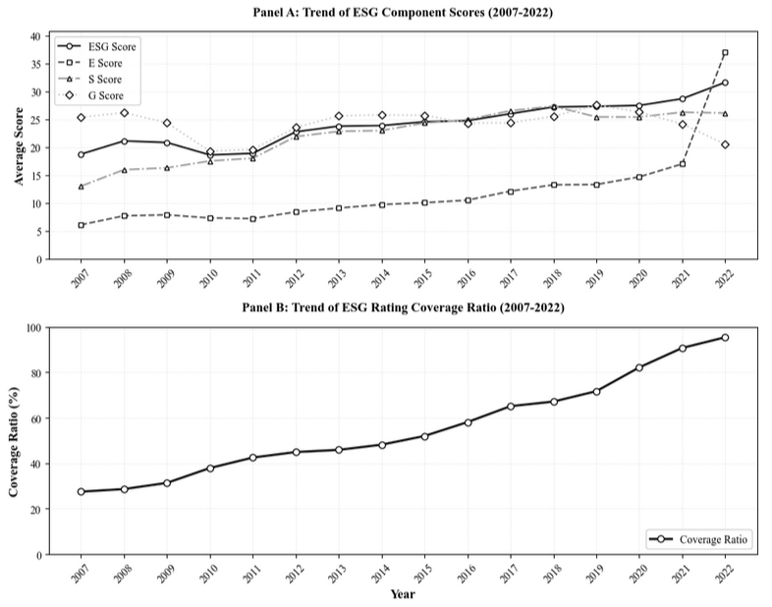
Panel B: Trend of ESG Rating Coverage Ratio (2007-2022)



Figure C2: ESG Rating Coverage Ratio by GICS Industry (2007–2022)

Panel A figure illustrates the ESG rating coverage ratio across 11 GICS Level-1 industries based on Wind industry classification as of February 2025. The coverage ratio is defined as the proportion of firms within each industry that have available ESG ratings in the Wind database during the sample period from 2005 to 2022. Real Estate and Energy exhibit the highest ESG coverage ratios, while Information Technology and Telecommunication Services show relatively lower coverage. The figure highlights substantial cross-industry variation in ESG data availability.

Panel B figure illustrates the evolution of ESG rating coverage ratios across 11 GICS Level-1 industries from 2005 to 2022, based on Wind industry classification as of February 2025. The coverage ratio is defined as the proportion of firms within each industry that have available ESG ratings in the Wind database in a given year. The figure shows that ESG coverage increased steadily across all industries dramatically increase around 2020, with Real Estate and Energy reaching nearly complete coverage by 2022, while Information Technology and Telecommunication Services exhibited relatively slower adoption, which is consistent with the ESG Disclosure Reform (2020). The coverage ratio drops to zero after 2022 due to incomplete or pending data updates.

ESG Rating Coverage Ratio by GICS Industry (2007–2022)
Panel A: ESG Rating Coverage Ratio by GICS Industry
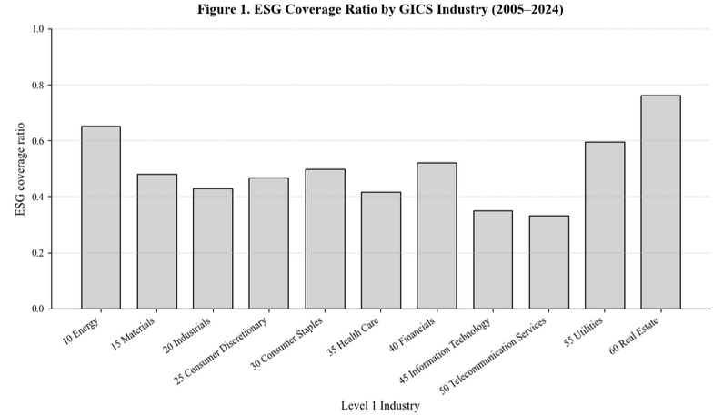
Panel B: ESG Rating Coverage Ratio by Industry (2007-2022)
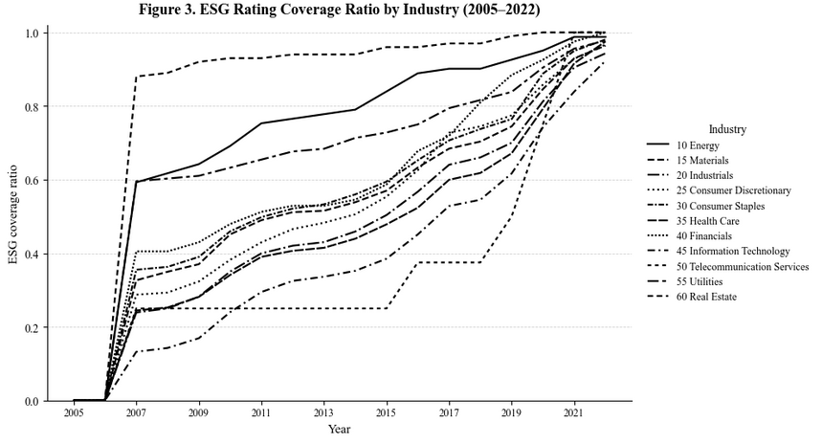

Figure C3. Average ESG Ratings by Industry (2007–2022)

This figure presents the average ESG rating by GICS Level-1 industry, based on the CNRDS database as of February 2025. Consumer Staples, Materials, and Health Care exhibit the highest average ESG scores, reflecting stronger sustainability disclosure and compliance practices. By contrast, Real Estate and Telecommunication Services show lower ESG performance, indicating slower progress in ESG adoption across these sectors.

Average ESG Ratings by Industry (2007–2022)
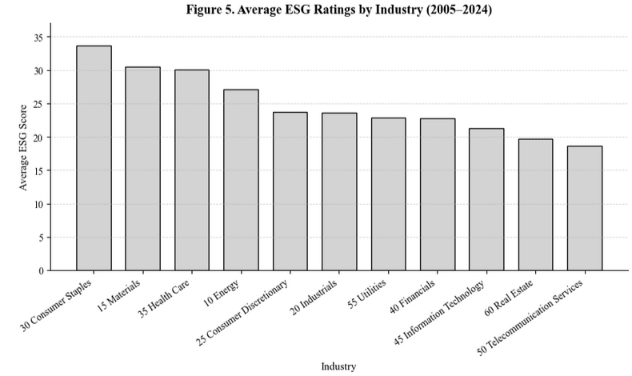

Figure C4. Annual Average ESG Ratings by Year (2007–2022)
This figure presents the annual average ESG ratings of all listed firms in the sample from 2007 to 2022, based on the Wind database as of February 2025. The overall upward trend indicates continuous improvement in ESG performance among Chinese listed firms, particularly after 2020, reflecting increased regulatory emphasis and market awareness of sustainability reporting.

Annual Average ESG Ratings by Year (2007–2022)
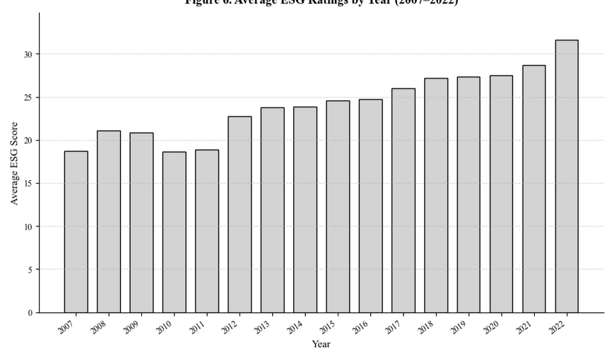

Figure C5. Industry-Level ESG Rating Trends (2007–2022).

This figure plots the time-series evolution of average ESG ratings across 11 GICS Level-1 industries based on Wind data. ESG ratings exhibit a broad upward trend over 2007–2022, reflecting the progressive strengthening of disclosure practices and the expanding adoption of sustainability reporting in China. Industries such as Consumer Staples, Materials, and Health Care consistently maintain the highest ESG scores, suggesting more mature reporting standards and structured governance frameworks.

By contrast, Real Estate and Telecommunication Services remain at the lower end of the distribution, with Real Estate showing pronounced year-to-year volatility—likely reflecting heightened regulatory scrutiny, leverage cycles, and uneven disclosure quality in the sector. Energy and Industrials also rise steadily but remain in the mid-range, consistent with gradual improvements driven by environmental compliance requirements.

Notably, most industries experience a visible acceleration in ESG score growth after 2015, coinciding with China’s green-finance policy rollout and the increasing integration of ESG considerations into capital market regulation. This temporal pattern highlights both cross-industry heterogeneity and the policy-driven nature of ESG adoption in the Chinese A-share market.

Industry-Level ESG Rating Trends
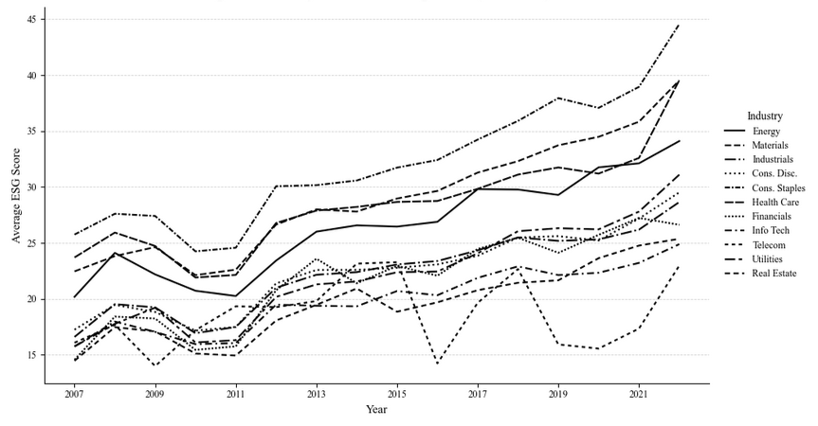

Figure C6. Average Industry-level E, S, and G Ratings (2007–2022)

This figure illustrates the average environmental (E), social (S), and governance (G) ratings by GICS Level-1 industries from 2007 to 2022, based on the Wind ESG database (as of February 2025).
Panel (A) reports the average Environmental (E) ratings, Panel (B) shows the average Social (S) ratings, and Panel (C) presents the average Governance (G) ratings.
Overall, Consumer Staples, Materials, and Health Care consistently achieve higher scores across dimensions, suggesting stronger ESG performance and disclosure. In contrast, Real Estate and Telecommunication Services exhibit lower averages, indicating slower ESG adoption in these sectors.

Average Industry-level E, S, and G Ratings (2007-2022)
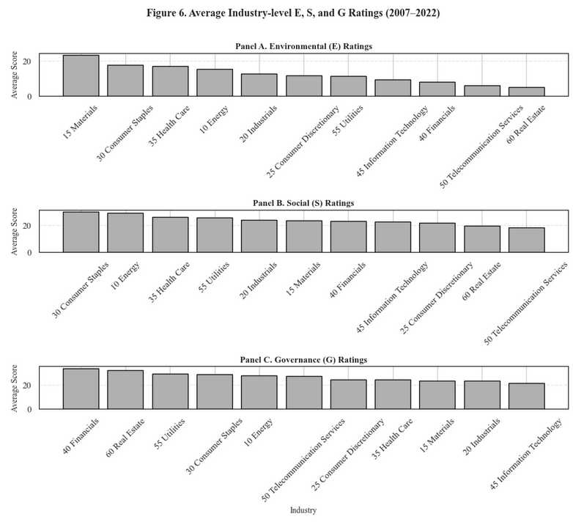

Figure C7. Industry-level Environmental (E) Ratings Trends (2007–2022)

This figure illustrates the time-series evolution of Environmental (E) ratings across 11 GICS Level-1 industries in China from 2007 to 2022, based on data from the Wind ESG database (as of February 2025).
The E ratings reflect firms’ performance in environmental management, emissions reduction, resource efficiency, and disclosure transparency.

Overall, all industries exhibit an upward trajectory in their Environmental (E) ratings, with a particularly sharp rise after 2020, coinciding with China’s national “carbon neutrality” pledge and the implementation of stricter ESG disclosure regulations.
The Materials and Consumer Staples industries show the most significant improvement, suggesting active adoption of sustainable production practices and stronger compliance with environmental reporting standards.
In contrast, sectors such as Telecommunication Services and Real Estate demonstrate relatively modest progress, indicating slower integration of environmental sustainability into their operational strategies.

E Rating of Industries (Yearly Trend)
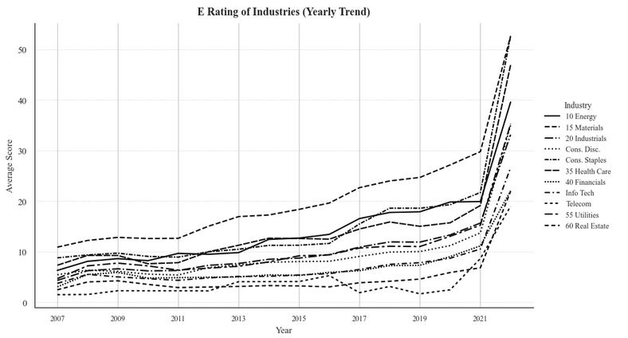

Figure C8. Industry-level Social (S) Rating Trends (2007–2022)

This figure presents the annual evolution of Social (S) ratings across 11 GICS Level-1 industries in China from 2007 to 2022, based on data from the Wind ESG database (as of February 2025). The S ratings evaluate firms’ performance in areas such as employee welfare, labor standards, community engagement, product responsibility, and social disclosure practices.

Overall, the Social (S) dimension shows a consistent upward trend across most industries, reflecting the strengthening of corporate social responsibility (CSR) frameworks and improved disclosure requirements in China.
The Consumer Staples and Energy sectors record the highest S scores, driven by enhanced labor protection policies and social sustainability initiatives, while Telecommunication Services and Real Estate remain at the lower end, suggesting slower progress in integrating social responsibility measures into their operations. The acceleration of S performance after 2015 aligns with the introduction of domestic CSR guidelines and the growing importance of human capital management in corporate governance reforms.

S Rating of Industries (Yearly Trend)
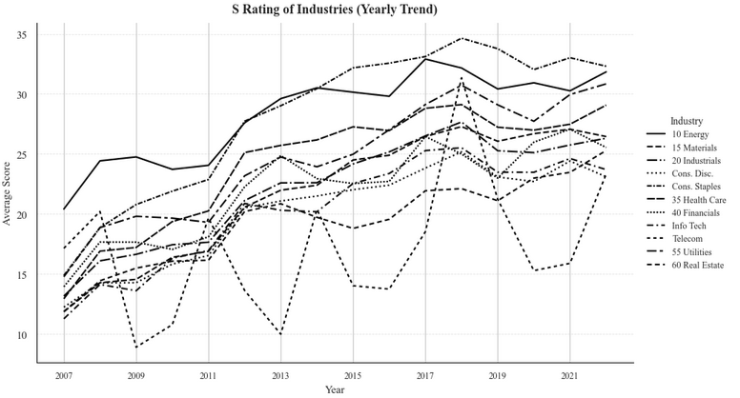

Figure C9. Industry-level Governance (G) Rating Trends (2007–2022)

This figure illustrates the annual evolution of Governance (G) ratings across 11 GICS Level-1 industries from 2007 to 2022.The Governance (G) score measures corporate board structure, management accountability, transparency, and shareholder protection practices.
Solid and dashed lines represent different industries’ average G scores by year, smoothed to highlight cross-industry variation and long-term governance trends.

The figure shows a moderate upward trend in governance quality across most industries from 2007 to 2020, consistent with the gradual institutionalization of ESG reporting and corporate governance reforms in China.
Industries such as Financials, Utilities, and Real Estate maintain relatively high and stable G ratings, indicating stronger internal control systems and greater compliance with governance codes. In contrast, Information Technology and Materials sectors display lower average G scores and greater volatility, reflecting less mature governance frameworks and potentially weaker regulatory oversight.

The decline observed after 2021 is largely attributed to data coverage limitations in the Wind ESG database, rather than a structural deterioration in governance quality.

G Rating of Industries (Yearly Trend)
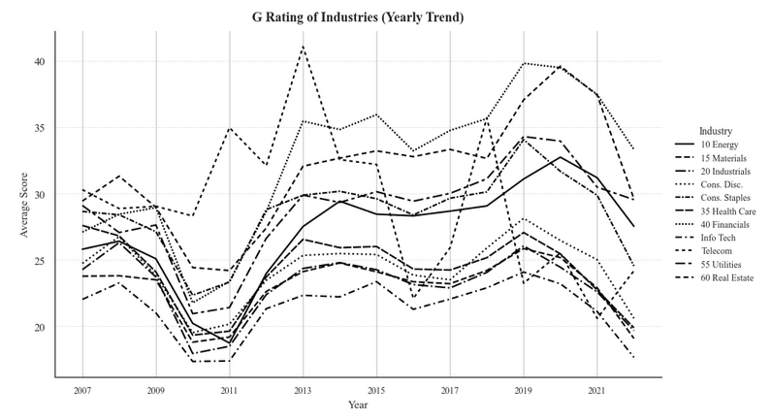

Figure C10: Distribution of E, S, and G Scores by Dimension

This figure visualizes the cross-sectional distribution of Environmental (E), Social (S), and Governance (G) ratings aggregated at the industry level. The distributions are estimated using violin plots based on firm-level average scores over the 2007–2022 period from the CNRDS dataset. The internal dashed lines indicate the first quartile, median, and third quartile of each distribution.

Distribution of E, S, and G Scores by Dimension
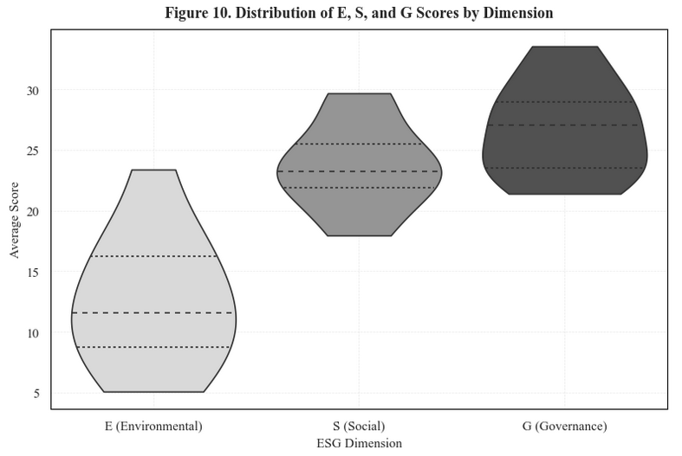

Figure C11. Quantile Plot of ESG Scores (E, S, G)

This figure compares the 25th, 50th, and 75th percentile values of firm-level ESG dimension scores, illustrating the cross-sectional distributional structure across the Environmental (E), Social (S), and Governance (G) components. Consistent with the quantile estimates reported in Table 13, the Social and Governance dimensions display substantially higher central and upper-quartile values than the Environmental dimension, indicating stronger disclosure depth and greater score dispersion for S and G.

The steep upward shift from E to S across all quantiles highlights that environmental performance remains the weakest and most unevenly reported dimension among Chinese firms. By contrast, the relatively tighter interquartile range between S and G suggests more uniform reporting standards and lower cross-sectional variability in these two pillars. Together, the quantile patterns reveal meaningful divergence in disclosure quality and score concentration across ESG dimensions.

Quantile Plot of ESG Scores (E, S, G)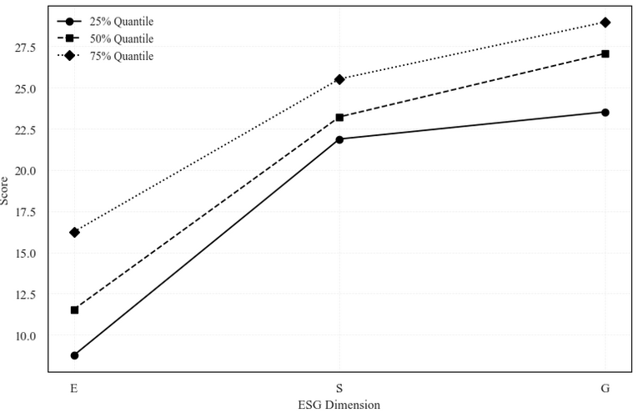

Figure C12. Spearman Rank and Kendall Rank Correlation (E, S, G)

Panel A (Figure A. Spearman Rank Correlation (E/S/G)) visualizes the Spearman rank correlation matrix across Environmental (E), Social (S), and Governance (G) dimensions at the industry level. The strong positive correlation between E and S (ρ = 0.76) indicates similar ranking patterns across environmental and social dimensions, whereas Governance (G) rankings show weaker or negative associations with the other two dimensions.

Panel B (Figure B. Kendall Rank Correlation (E/S/G)) shows the Kendall τ rank correlation matrix for the same dimensions. The results are consistent with the Spearman correlations, reinforcing the robustness of the E–S concordance and the relative independence of the G component.

Spearman Rank and Kendall Rank Correlation (E, S, G)
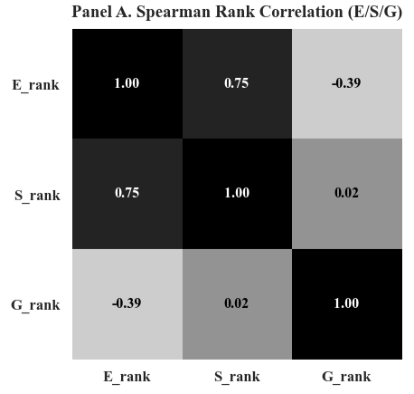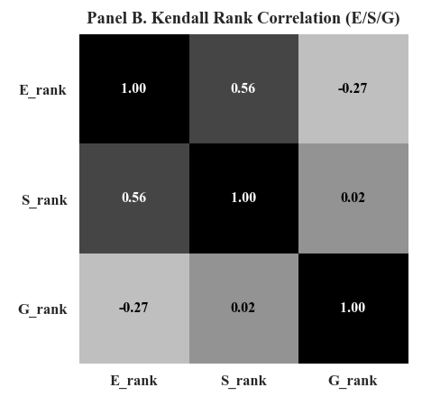

Figure C13. Data Availability Comparison: Firms With vs Without ESG Ratings

This figure presents the proportion of missing data for key financial variables, stratified by ESG rating coverage. The results reveal a stark disparity in data completeness between the two groups. Firms without ESG ratings exhibit near-total data absence, with 100% missing rates across all three financial metrics—market capitalization, price-to-book ratio, and daily returns. In contrast, firms covered by ESG ratings maintain high data integrity, with missing rates of only 2.2% for market capitalization and daily returns, and 36.3% for price-to-book ratios. This systematic pattern indicates that the absence of ESG ratings serves as a strong proxy for overall data unavailability, suggesting that non-ESG-rated firms either represent non-operational entities, have delisted status, or maintain minimal public disclosure. These findings underscore the presence of significant selection bias in ESG data coverage and highlight the importance of accounting for such systematic differences in empirical research.

Data Availability Comparison: Firms With vs Without ESG Ratings 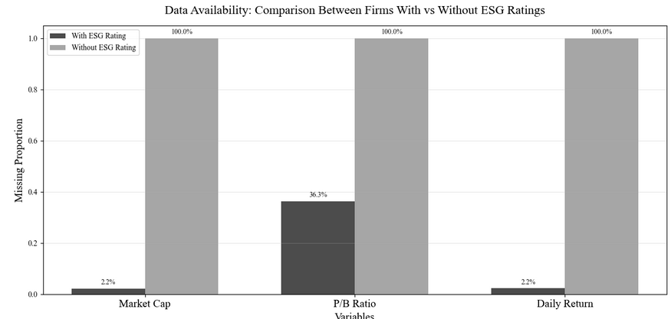

Figure C14. Annual and Cumulative Returns of High–Low (D1−D5) Portfolios, 2007–2022

Panel A plots annual excess returns (D1–D5) of ESG and its three sub-pillars (E, S, G). Positive values indicate that firms with higher ESG scores outperform low-ESG firms in that year. Panel B shows cumulative returns from annually compounded High–Low portfolios. The results reveal that governance (G) and environmental (E) dimensions exhibit persistent underperformance, while social (S) returns fluctuate around zero, suggesting heterogeneous and time-varying ESG premiums.

Annual and Cumulative Returns of High–Low (D1−D5) Portfolios, 2007–2022
Panel A. Annual Returns of High-Low (D1-D5) Portfolios
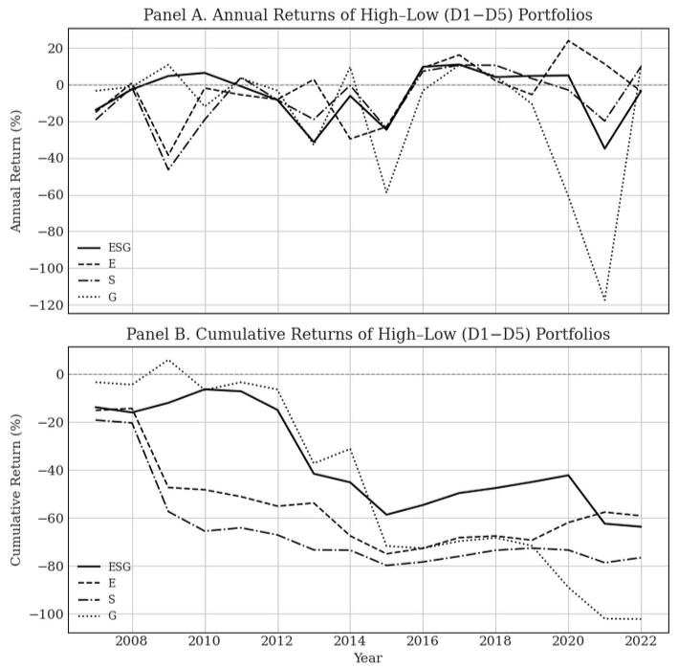
Panel B. Cumulative Returns of High-Low (D1-D5) Portfolios


Figure C15. Annual Volatility and Sharp Ratio of High–Low (D1−D5) Portfolios, 2007–2022

Panel A plots the annual return volatility of High–Low (D1–D5) portfolios constructed from ESG and its three sub-pillars (Environmental E, Social S, and Governance G) between 2007 and 2022. The volatility levels capture the risk dispersion of excess returns between the highest- and lowest-rated firms within each dimension. While all series exhibit time-varying volatility, the Governance (G) factor displays consistently higher volatility—particularly during 2013 and 2021—indicating that governance-related returns are more sensitive to market sentiment and structural shocks. In contrast, ESG-aggregate and E/S sub-portfolios show more moderate and stable volatility patterns.

Panel B shows the corresponding annual Sharpe ratios (rₓ = 0), measuring risk-adjusted performance of High–Low portfolios. Across the sample period, Sharpe ratios fluctuate substantially, with multiple years of negative values, suggesting that high-rated ESG firms underperform low-rated ones after accounting for volatility. Notably, the G pillar demonstrates the lowest and most volatile Sharpe ratios, driven by its larger downside swings, whereas E and S pillars occasionally deliver short-term positive risk-adjusted gains (e.g., 2016–2018). Overall, the results reveal heterogeneous and time-varying ESG premiums, where the governance and environmental dimensions dominate downside risks while the social pillar contributes transient improvements in portfolio efficiency.

Annual Volatility and Sharp Ratio of High–Low (D1−D5) Portfolios, 2007–2022
Panel A. Annual Volatility of High-Low (D1-D5) Portfolios
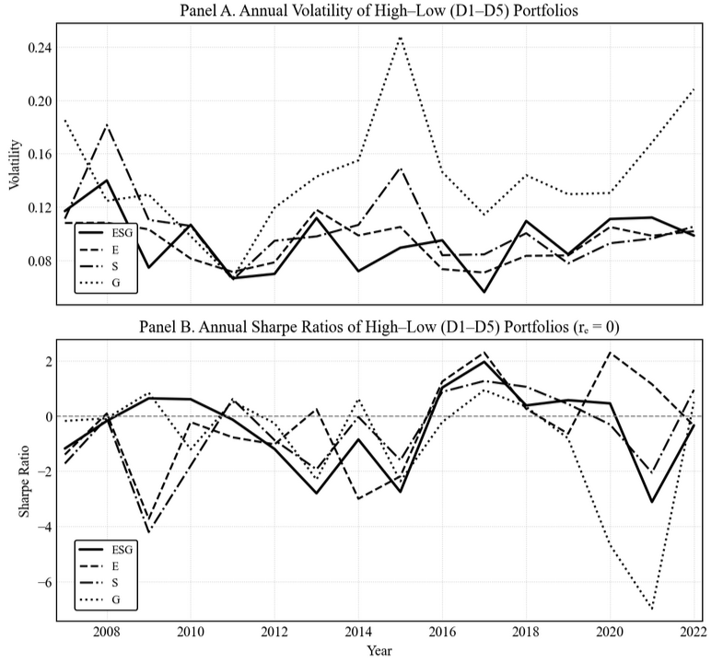
Panel B. Annual Sharp Ratios of High-Low (D1-D5) Portfolios (rₓ = 0)


Figure C16. Annual Turnover of High–Low (D1−D5) Portfolios, 2007–2022

This figure plots the annual turnover ratios of High–Low (D1–D5) portfolios constructed for the overall ESG score and its three sub-pillars (Environmental E, Social S, and Governance G) from 2008 to 2022. Turnover ratio measures the fraction of portfolio constituents replaced each year when rebalancing the long–short portfolios. A higher turnover ratio indicates greater portfolio reallocation intensity, often implying higher transaction costs and lower implement ability.

Among the four dimensions, the Governance (G) portfolio exhibits the highest and most volatile turnover, particularly after 2010, suggesting that governance-related firm characteristics change more frequently and are more sensitive to market sentiment. In contrast, the Environmental (E) portfolio maintains the lowest and most stable turnover, reflecting more persistent firm rankings in environmental scores. The Social (S) and aggregate ESG portfolios show moderate turnover dynamics over time, with slight increases during market stress periods such as 2020–2022. Overall, these patterns indicate heterogeneous portfolio stability across ESG pillars, consistent with the view that ESG components differ in persistence and information turnover.

Turnover Ratios of High-Low (D1-D5) Portfolios
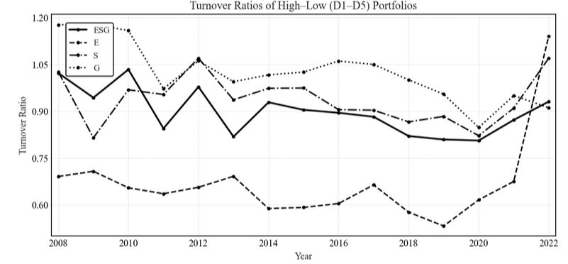

Figure C17. ESG Event Distribution and Market Response

Panel A reports the annual distribution of ESG-related events (upgrades, downgrades, and initiations) from 2007 to 2022. The steady rise in total counts indicates the rapid expansion of ESG coverage in China, particularly after 2018. Panel B presents the trend of ESG events by type. Upgrade events consistently exceed downgrades, reflecting continuous improvement in firms’ ESG performance. Initiations surge in 2010, 2016, and 2020, corresponding to key enhancements in ESG disclosure requirements. Panel C illustrates monthly portfolio returns around ESG events. Initiation events show the strongest and most volatile positive returns, implying higher information content. In contrast, upgrades and downgrades exhibit smaller, symmetric reactions, suggesting limited market sensitivity to incremental ESG score changes.

ESG Event Distribution and Market Response
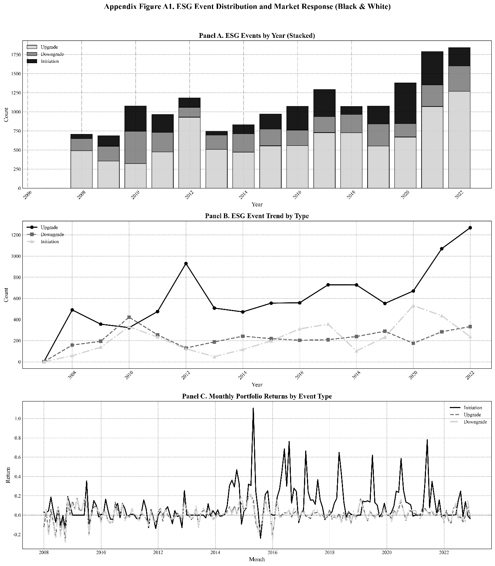

Figure C18. Monthly Realized Volatility: ESG H–L Portfolio vs. Major Market Indices

This figure plots the time-series of monthly realized volatility for the ESG high-minus-low (H–L) portfolio alongside three major Chinese stock indices—CSI 300, SSE Composite, and SZSE Component—from 2007 to 2022. The ESG H–L portfolio consistently exhibits lower volatility than the benchmark indices, indicating greater stability and weaker exposure to market-wide shocks. Volatility spikes observed during 2015–2016 and 2020 correspond to the stock market turbulence and the COVID-19 outbreak, respectively, but the ESG factor remained relatively resilient throughout these episodes, suggesting its defensive risk characteristics.

Monthly Realized Volatility: ESG H–L Portfolio vs. Major Market Indices 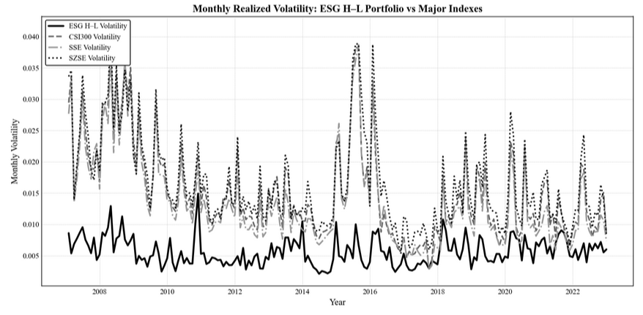

Figure C19. Heatmap of ESG Coverage by Industry and Year (2007–2022)

This figure presents a heatmap of ESG coverage ratios for all listed firms across 11 industries from 2007 to 2022. Darker shades indicate higher coverage, with values normalized between 0 and 1. The figure illustrates a clear two-phase evolution: (i) initial selective participation concentrated in energy-, resource-, and regulation-intensive sectors in the late 2000s, followed by (ii) rapid post-2015 diffusion across previously underrepresented industries, coinciding with the introduction of China’s Green Finance Guidelines and subsequent ESG disclosure reforms. By the early 2020s, ESG coverage converges across nearly all sectors, indicating the institutionalization of sustainability disclosure in China’s capital market.

Heatmap of ESG Coverage by Industry and Year (2007–2022)
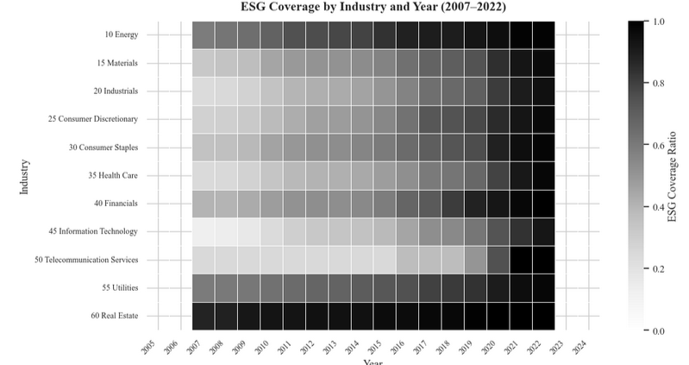

Figure C20. Rolling 5-Year Average of ESG High-Low Returns

The figure plots the five-year rolling average of annual ESG High–Low (D1 – D5) factor returns. The pattern reveals pronounced time variation: negative values in the early 2010s, a strong rebound around the 2016–2020 green finance expansion, and a subsequent decline after 2021. The episodic behavior suggests that ESG-related return premia in China are regime-dependent and closely aligned with shifts in regulatory intensity and policy attention.

Rolling 5-Year Average of ESG High-Low Returns
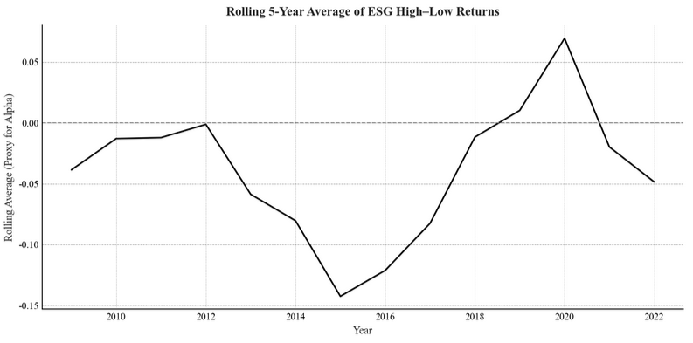

Figure C21. 24-Month Rolling Alpha of the Social (S) Factor with COVID-19 Policy Timeline

This figure plots the 24-month rolling alpha from Fama–French five-factor regressions for the Social (S) High–Low portfolio from 2017 to 2022, overlaid with key COVID-19 policy milestones—namely the outbreak (January 2020), emergency vaccine approval (July 2020), the beginning of the recovery phase (August 2020), the post-reopening transition (May 2021), and the termination of the Zero-COVID policy (December 2022). The rolling alpha turns sharply positive during the outbreak period, indicating a short-lived crisis-resilience premium for socially responsible firms. As the pandemic stabilizes, the rolling alpha declines and becomes negative in both the recovery and post-reopening phases, consistent with the regression results reported in figure. These dynamics illustrate the state-contingent and transitory nature of the S-factor premium—strengthening under acute macro uncertainty and reversing once market conditions normalize.

The Social (S) factor is plotted here because it is the only ESG pillar that exhibits a clear sign reversal across COVID-19 stages—positive alpha during the outbreak and negative alpha during the recovery and post-reopening phases—making it uniquely informative for visualizing the crisis-response dynamics documented in the regressions. Governance (G) and aggregate ESG factors show consistent underperformance across subperiods, and thus rolling-alpha plots provide limited additional interpretive value relative to the S-factor.

24-Month Rolling Alpha of Social (S) Factor with COVID-19 Policy Timeline
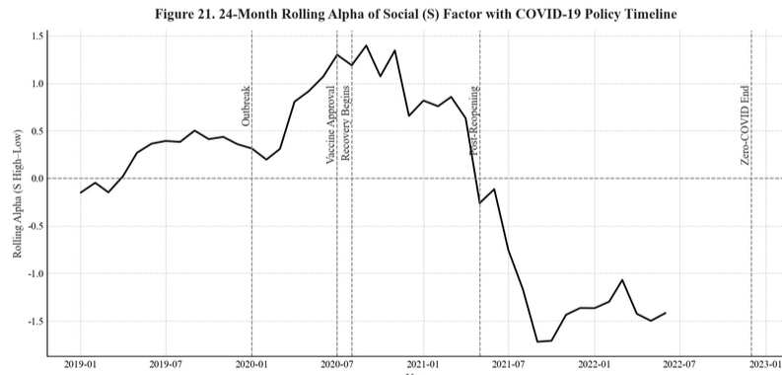

Figure C22. 24-Month Rolling Alpha of Governance (G) Factor with Policy & Housing Cycle Timeline

This figure plots the 24-month rolling alpha from Fama–French five-factor regressions for the Governance (G) High–Low portfolio between 2018 and 2023, overlaid with key policy and housing-market turning points, including the pre-crackdown baseline period (2018–2020), the implementation of the Three Red Lines leverage restriction (August 2020), the credit tightening associated with the Ant Group IPO suspension (late 2020–mid 2021), the first housing-market downturn (2021H2), the short-lived rebound in early 2022, and the renewed decline beginning in March 2022. Consistent with the regression results in Table 30, the rolling alpha is positive prior to the crackdown, turns sharply negative during the tightening phase, rebounds around the onset of the housing-price recovery, and declines again as credit conditions weaken. This nonmonotonic pattern indicates that the pricing of the G factor is highly sensitive to credit conditions and real estate capitalization dynamics, rather than to regulatory announcements alone.

The Governance (G) factor is plotted here because it is uniquely concentrated in property developers and financial institutions and therefore is the only ESG pillar that exhibits clear cyclical responses to both policy tightening and housing-market conditions. Unlike the Environmental and Social pillars, whose returns display limited sensitivity to leverage-driven shocks, the G factor consistently prices sectoral liquidity risk: it underperforms during credit contractions and housing downturns, and temporarily rebounds during easing episodes. As such, the rolling-alpha pattern visualized here provides direct evidence for the leverage-sensitive and state-contingent nature of governance-related premia documented in the regression analyses.

24-Month Rolling Alpha of Governance (G) Factor with Policy & Housing Cycle Timeline
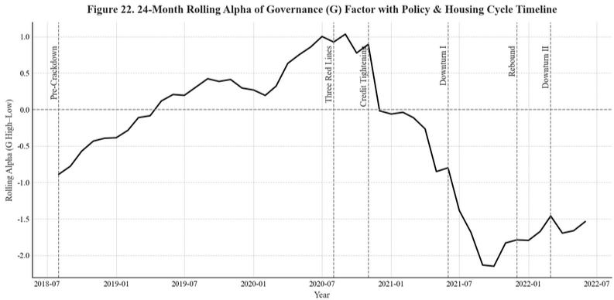

Figure C23. 24-Month Rolling Alpha of Environmental (E) Factor with Green Development Policy Timeline

This figure plots the 24-month rolling alpha from Fama–French five-factor regressions for the Environmental (E) High–Low portfolio from 2016 to 2022, overlaid with major green-development policy milestones in China. Key events include the baseline period before large-scale environmental policy reinforcement (2015–2017), the elevation of “ecological civilization” during the 19th National Congress (October 2017), the regulatory tightening that followed the First Plenary Session (March 2018), the late-cycle environmental rectification phase (2018–2019), the decline in new-energy-vehicle (NEV) sales during subsidy withdrawal (September–December 2019), the stabilization period after policy adjustments (2019–2020), the announcement of the “dual-carbon” targets (September 2020), and the subsequent stabilization phase (2021–2022). Consistent with the regression evidence in Table 31, the rolling alpha rises sharply during periods of strong policy promotion—such as the post-Congress environmental push (2017–2018) and the dual-carbon announcement (2020–2021)—indicating that the E factor delivers short-lived positive abnormal returns when policy support for green industries intensifies. In contrast, the rolling alpha turns negative or remains muted during subsidy withdrawal (2019) and in the post-2021 stabilization period, reflecting a normalization of valuations once policy novelty fades and fiscal incentives recede.

Only the Environmental (E) factor is plotted here because it is the ESG pillar most directly linked to China’s state-led green-development agenda and exhibits clear policy-cycle-dependent fluctuations. Unlike the Social factor, which responds primarily to crisis-driven sentiment, or the Governance factor, which reflects leverage-risk exposure, the E factor prices shifts in environmental policy emphasis, subsidy regimes, and carbon-neutrality initiatives. As such, the rolling-alpha pattern visualized here provides direct evidence that environmental-related premia in China are episodic, policy-backed, and highly sensitive to changes in national strategic priorities.

24-Month Rolling Alpha of Environmental (E) Factor with Green Development Policy Timeline
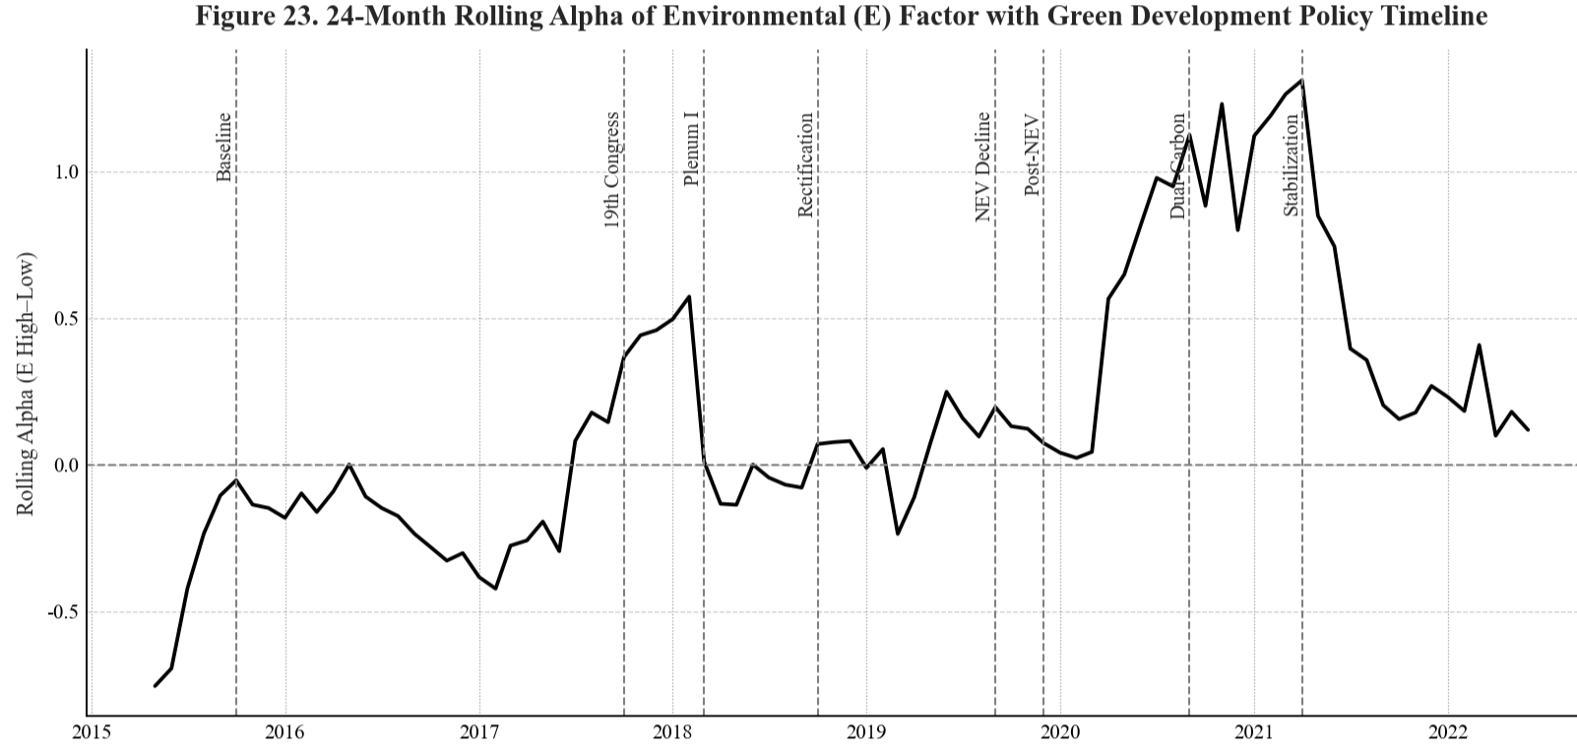

Figure C24. Cross-Database Comparison of ESG Ratings: CSMAR vs. CNRDS (2015–2020)

Panel A shows that raw ESG scores from CSMAR and CNRDS exhibit virtually no systematic relationship. The points form a wide, unstructured cloud with no visible linear pattern, reinforcing the low rank (ρ = 0.066) and level (r = 0.057) correlations. In Panel B, percentile normalization does not meaningfully improve alignment. If the two rating systems were consistent in relative ranking, the scatter would cluster around an upward-sloping 45° pattern; instead, the plot remains horizontally dispersed, indicating that firms ranked highly by one provider are not similarly ranked by the other.

These figures visually confirm a key empirical message: ESG disagreement in China is structural, persistent, and unaffected by normalization. Thus, the weak/negative ESG return patterns documented in the paper are unlikely to be artifacts of a particular scoring scale and instead reflect fundamental divergence in rating methodologies.

Cross-Database Comparison of ESG Ratings: CSMAR vs. CNRDS (2015–2020)
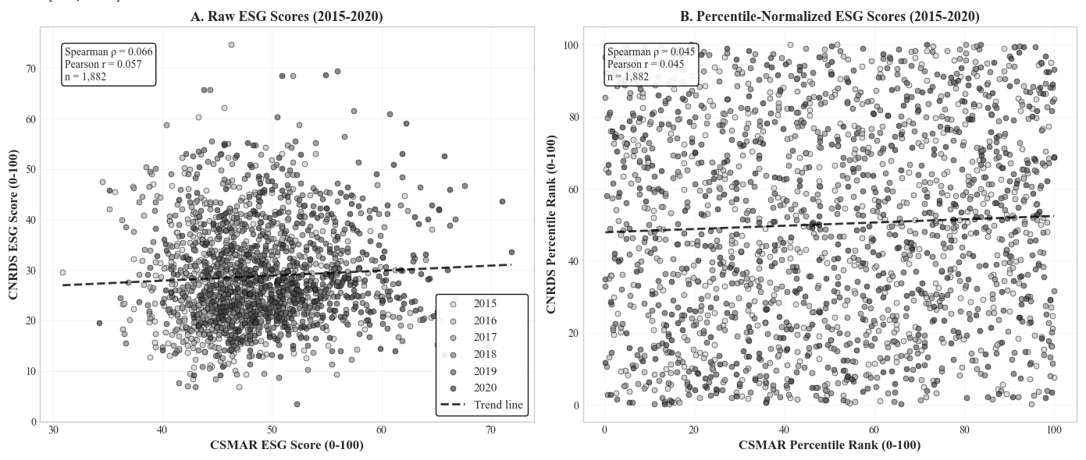

Figure C25. Correlation Heatmaps between ESG and Fama–French Five Factors

This figure illustrates the pairwise correlations between the constructed ESG-related High–Low (D10–D1) factor returns and the Fama–French five factors. Panel A shows the correlation of the overall ESG factor, while Panels B–D present the Environmental (E), Social (S), and Governance (G) sub-pillars, respectively.

Across all panels, ESG-related factors exhibit consistent patterns: high negative correlation with SMB (size), indicating that high-ESG portfolios tilt toward large-cap firms; and strong positive correlation with RMW (profitability), implying that ESG portfolios load heavily on profitable firms. Mild positive correlations with HML (value) suggest limited association with the value factor. Among all sub-pillars, the Governance (G) factor displays the largest correlations (|r| up to 0.63) with profitability and value, consistent with its stronger link to firm fundamentals. Darker shades represent stronger correlations (positive or negative). The heatmaps are based on value-weighted monthly High–Low portfolio returns from 2007 to 2022.

Correlation Heatmaps between ESG and Fama–French Five Factors 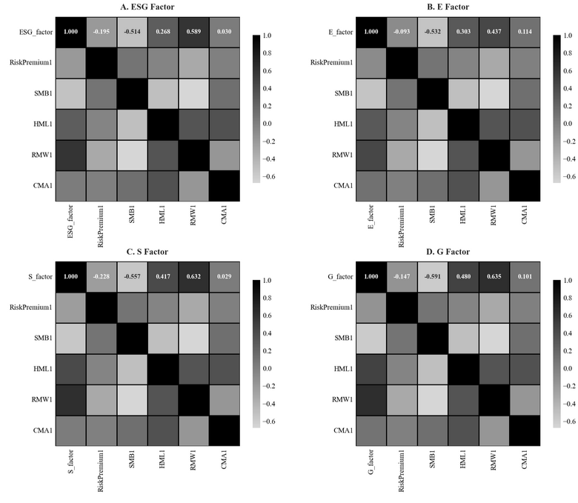

See Report to the 19th National Congress of the CPC (October 18, 2017).
Constitutional Amendment of the People’s Republic of China, adopted March 11, 2018.
State Council Executive Meeting decision, March 31, 2020; see Beijing News (2020).
President Xi Jinping’s address at the 75th UN General Assembly, September 22, 2020, reaffirmed China’s “dual-carbon” targets (peak CO₂ by 2030, neutrality by 2060).

